**“Doctor’s Appointment System”**



**BY**

25260038 – MR. DHRUMIL D BHALANI

25260224 – MR. UTSAV P SALIYA

**UNDER GUIDANCE OF**

Mr. Gaurang Bhatt

**SUBMITTED TO**

SHREE SWAMINARAYAN COLLEGE OF COMPUTER SCIENCE

**FOR DEGREE OF**

BACHELOR OF COMPUTER APPLICATIONS



**S**hree **S**waminarayan **C**ollege **o**f **C**omputer **S**cience

**(Affiliated to M. K. Bhavnagar University)**

**GURUKUL CAMPUS, SARDARNAGAR, BHAVNAGAR-364001**



NAAC Accreditation Grade “B” Gurukul Campus, Sardarnagar,

Bhavnagar. 364001. (Guj)

Phone: 0278-2568222

Fax: 0278-2568222

e-mail: director@swamigurukul.com

SHREE SWAMINARAYAN visit us at: [www.swamigurukul.com](http://www.swamigurukul.com)  **COLLEGE OF COMPUTER SCIENCE**  (Affiliated to Maharaja Krishnakumarsinhji Bhavnagar University)

# 

# 

# COLLEGE CERTIFICATE

This is to certify that Mr./Ms._________________________________

Seat No. ______________ student of Bachelor of Computer Application (BCA) Semester-VI, in our institute has successfully completed the project assigned to his/her at entitled ___________________________ _________________________________________________________

during the period November-2022 to March-2023 as a part of Bachelor of Computer Application (BCA) syllabus (2022-2023).

Date:

Place: Bhavnagar Project Guide I/C Principal



NAAC Accreditation Grade “B” Gurukul Campus, Sardarnagar,

Bhavnagar. 364001. (Guj)

Phone: 0278-2568222

Fax: 0278-2568222

e-mail: director@swamigurukul.com

SHREE SWAMINARAYAN visit us at: [www.swamigurukul.com](http://www.swamigurukul.com)  **COLLEGE OF COMPUTER SCIENCE**  (Affiliated to Maharaja Krishnakumarsinhji Bhavnagar University)

# 

# 

# COLLEGE CERTIFICATE

This is to certify that Mr./Ms._________________________________

Seat No. ______________ student of Bachelor of Computer Application (BCA) Semester-VI, in our institute has successfully completed the project assigned to his/her at entitled ___________________________ _________________________________________________________

during the period November-2022 to March-2023 as a part of Bachelor of Computer Application (BCA) syllabus (2022-2023).

Date:

Place: Bhavnagar Project Guide I/C Principal

* Preface

1. In our college project is an subject and it was studied by very strictly. In a project subject

we can be study about the how to develop an project?,selecting popular and latest definition of the project.

1. They could also explain and discover the benefits of the project documentation. In project documentation they could teach about the Data flow diagram , Entity – relationship diagram and also testing and requirement gathering.
2. A **Doctor’s Appointment System** can prove to be a boon to doctors and patients alike. For those among us who have seen the waiting room of busy doctors, it will draw memories of patients and their attendants crowding around the receptionist.
3. Many times, it was based on who was able to throw their weight around and seize the opportunity to stride in to meet the doctor even before the earlier patient had walked out. In some cases, tokens were given out that represented our number in the queue.
4. Widespread use of mobile phones and the internet has driven the need for doctors to offer the facility of online appointments booking – a far superior option for both doctors and patients. We have listed below the key advantages of using an online doctor appointment booking system.

* Acknowledgement

1. Every work that one completed successfully on the constant encouragement, good will and support of the people around. I, hereby, avail this opportunity to express my heartfelt gratitude to a number of people who extended their valuable time, full support and cooperation in developing this project. I convey my heartfelt gratitude to my collage **“Shree Swaminarayan College of Computer Science”** for giving me this precious opportunity to work for the real-time project.
2. I wish to express my deep sense of gratitude and honour toward head of **Maharaja Krishna Kumarsinhji Bhavnagar University** for given chance me to work with study.
3. I would also like to extend my gratitude to the principal sir **Mr. Paresh Rathod,** and academic head **Dr. Kalpesh Gundigara,** who gave me the support throughout to the development this wonderful project on the topic **“Doctor’s Appointments System”.**
4. I owe the success of the project to my Project Guide, **Mr. Gaurang Bhatt,** for providing excellent guidance for this project. He is one of the major sources behind the success of the project.
5. I would like to express my special thanks to our mentor **Mr. Sagar Vala** for his time and efforts he provided throughout the year. Your useful advice and suggestions were really helpful to me during the project’s completion. In this aspect, I am eternally grateful to you.
6. Finally, yet importantly, I would like to express my heartfelt thanks to my beloved parents for their blessings, my Friends/Classmates for their help and wishes for the successful completion of this project.

Table of Content

|  |  |  |  |
| --- | --- | --- | --- |
| **SR NO.** | **DESCRIPTION** | | **PAGE NO.** |
| **01** | **INTRODUCTION** | | **09-15** |
|  | 1.1 | Background | 11 |
|  | 1.2 | Objective | 12 |
|  | 1.3 | Purpose | 13 |
|  | 1.4 | Scope | 14 |
|  | 1.5 | Applicability | 15 |
| **02** | **Requirement & Analysis** | | **16-24** |
|  | 2.1 | Problem Definition | 17 |
|  | 2.2 | Requirement Specification | 17 |
|  | 2.3 | Functionality as each user | 18 |
|  | 2.4 | Planning & Scheduling | 20 |
|  | 2.5 | Hardware & Software requirement | 20 |
|  | 2.6 | Feasibility study | 21 |
|  | 2.7 | Fact Finding Technique | 23 |
| **03** | **System Design** | | **25-60** |
|  | 3.1 | What is system design? | 26 |
|  | 3.2 | Over all system design using designing tool | 27 |
|  | 3.3 | Data Flow Diagram | 33 |
|  | 3.4 | E-R Diagram | 43 |
|  | 3.5 | Data Dictionary | 45 |
|  | 3.6 | Input-Output Design | 49 |
| **04** | **Testing & Implementation** | | **61-85** |
|  | 4.1 | Testing Definition | 62 |
|  | 4.2 | Testing Plan | 63 |
|  | 4.3 | Testing Approach | 64 |
|  | 4.4 | Test Cases | 68 |
|  | 4.5 | Implementation Approach | 82 |
| **05** | **Conclusion** | | 86-89 |
|  | 5.1 | Conclusion | 87 |
|  | 5.2 | Future Scope of system | 88 |
|  | 5.3 | Limitation of System | 89 |
|  | 5.4 | Bibliography | 89 |

Table of Figure

FIGURE-1: - DFD CONTEXT LEVEL…………………………………………….………35

FIGURE-2: - DFD LEVEL-1 [ADMIN]……………………………………………………36

FIGURE-3: - DFD LEVEL-1 [DOCTOR]………………………………………………….37

FIGURE-4: - DFD LEVEL-1 [PATIENT]………………………………………………….38

FIGURE-5: - DFD LEVEL-2 [ADMIN 2.0]……………………………………….……….39

FIGURE-6: - DFD LEVEL-2 [ADMIN 3.0]…….………………………………………….39

FIGURE-7: - DFD LEVEL-2 [ADMIN 4.0]………………………………………………..40

FIGURE-8: - DFD LEVEL-2 [ADMIN 7.0]………………………………………………..40

FIGURE-9: - DFD LEVEL-2 [DOCTOR 2.0]………………….…………………………..41

FIGURE-10: - DFD LEVEL-2 [PATIENT 6.0]…………………………………………….42

FIGURE-11: - E-R DAIGRAM…………………………………………………….……….44

FIGURE-12: - SCREEN-SHOT: - ADMIN LOGIN PAGE…………………….………….49

FIGHRE-13: - SCREEN-SHOT: - DASHBOARD PAGE…………………….……...……50

FIGURE-14 – SCREEN-SHOT: - ADD DOCTOR……………………………..………….51

FIGURE-15: - SCREEN-SHOT: - ADD MEDICAL SPECIALTIES………………………52

FIGURE-16: - SCREEN-SHOT: - SYSTEM SETTING PAGE…………………..………..53

FIGURE-17: - SCREEN-SHOT: - LOGIN PAGE………………………………..………...54

FIGURE-18: - SCREEN-SHOT: - APPOINTMENT LIST PAGE………………..………..55

FIGURE-19: - SCREEN-SHOT: - CHANGE PASSWORD PAGE…….………..…………56

FIGURE-20: - SCREEN-SHOT: - DOCTOR’S DETAILS PAGE……….………..………..57

FIGURE-21: - SCREEN-SHOT: - REGISTRATION PAGE……………….………….……58

FIGURE-22: - SCREEN-SHOT: - SET APPOINTMENT…………………….……….……59

FIGURE-23: - SCREEN-SHOT: - CHANGE PASSWORD [PATIENT SIDE]...…….……60

FIGURE-24: - UNIT TESTING……………………………………………………….…….64

FIGURE-25: - INTEGRATION TESTING…………………………………………....……64

FIGURE-26: - ACCEPTANCE TESTING…………………………………...………….….65

FIGURE-27: - SYSTEM TESTING……………………………………………………..….65

FIGURE-28: - BLACK-BOX TESTING……………………………………………..….….66

FIGURE-29: - WHITE-BOX TESTING………...…………………….....…………..……67

FIGURE-30: - GREY-BOX TESTING……………………………………………………67

FIGURE-31: - XAMPP CONTROL PANEL………………………………….…………..83

FIGURE-32: - NOTEPAD++…………………………………………….…..……………84

FIGURE-33: - MYSQL……………………………………………………………………85

Doctor’s Appointment System



CHAPTER: - 1

INTRODUCTION

1.1 BACKGROUND

1. The doctor appointment system is to provide patients or any user an easy way of booking a doctor’s appointment online.
2. According to us we find that today population and less availability of doctor's large number of patients unable to reach ones to doctor that we developed this project.
3. This web-based application that overcomes the issue of managing and booking appointment according to users/patients’ choice or demands.
4. The ability to set appointments with specific individuals will allow relationships to grow, build over time, and establish trust – which leads to improved experiences, positive interactions, and organizational growth.
5. The task sometimes becomes very tedious for the compounder or doctor himself in manually allotting appointments for the users as per their availability.
6. Patient can be easily to take appointments and also its information successfully registered within particular requirements.
7. Hence this project offers an effective solution where patients can view various booking slots available and select the preferred date and time.
8. This system also allows users to cancel their booking anytime.
9. Hence this project offers an effective solution where users
10. can view various booking slots available and select the preferred date and
11. time.
12. Hence this project offers an effective solution where users
13. can view various booking slots available and select the preferred date and
14. time.
15. Hence this project offers an effective solution where users
16. can view various booking slots available and select the preferred date and
17. time
18. The doctor appointment system managing the details of doctors, appointment, patient, doctor schedule etc.
19. The online doctor appointment system reduces the manual work for managing the doctor, appointment, patient etc.
20. It services available 24X7 and help patient to book appointments from anywhere, anytime, approx. the word.

1.2 OBJECTIVE OF SYSTEM

1. The doctor appointment system has been created because the problem that we are facing should be reduced to the patients and doctors in the clinic systems.
2. This software also stores all the patient’s details, doctors’ details, patients’ profile, etc.
3. The vision of the website application to give benefit to doctor and patient to reduce manual work.
4. The main objective to develop the software that reduce costs, reduce medical errors, reduce time consumption and enhance delivery of quality of care.
5. No knowledge is required for the user to use this system and also it is user-friendly.
6. Helping people to search for doctors and get appointment is our main objectives. User can search doctors which can make sure to find specific doctor with an easy task.
7. The doctor will able to see all their appointments, which are appoint to patients at this online platform.
8. The project an also help doctors to manage the schedule of their appointment with their patients.
9. Doctor appointment system website application will be ideal solution for this 21st century, because people are more use online website in their Mobile and Desktop to find the best doctors in various cities.
10. To build a system with perfection, requirement collection is a must. The study will give’s a clearer idea of people’s need and the system that we are planning to build as well as how much we are going to cover.
11. The document will also describe all the interactions between patients, doctors and admin.

1.3 PURPOSE OF SYSTEM

1. Planned approach towards working: -

* The working in the hospital will be well planned and organized. The data will be stored properly in data stores, which will help in retrieval of information as well as its storage.

1. Accuracy: -

* The level of accuracy in the system can be decided. Because here user take appointment and another user get appointment.

1. Reliability: -

* The reliability of the system will be high due to the above stated reasons. The reason for the increased reliability of the system is that now there would be proper storage of information.

1. Time saving: -

* Staff spends much time on the phone booking and can’t maintain appointment properly so booking through online by individuals save time as they no longer have to commit a part of their busy schedule to calling their medical, healthcare or wellness provider.
* As an example, typically phone booking system spends an average of four minute for booking ten patients. Where our system is will take less time.

1. Flexibility: -

* Online scheduling features advanced functionalities that are automated and improve the appointment reservation process and provide customers a simple healthcare flow. For example, time-saving.

1.4 SCOPE OF SYSTEM

1. The real of world wide web have spread across millions of households, so naturally, internet has become by far the platform for appoint the doctor today.
2. As the rapid change of the information technology, now hospital industry also need to enhance
3. their patients record and make it highly confidential.
4. As the rapid change of the information technology, now hospital industry also need to enhance
5. their patients record and make it highly confidential.
6. As the rapid change of the information technology, now hospital industry also need to enhance
7. their patients record and make it highly confidential.
8. As the rapid change of the information technology, now hospital industry also need to enhance
9. their patients record and make it highly confidential.
10. As a rapid change of an information technology, now hospital industry also needs to enhance that patient record and make it highly confidential.
11. Now a days when everything is online how is it possible that doctor’s appointment left web application behind?
12. There are lots of hospitals and clinics, who advertise online so idea behind development this application is that users\patients can take doctor’s appointment online.
13. These applications are not widely popular but in future, they have large scope of growth.
14. This website is an online doctor appointment through admin can maintain medical specialists, add doctor, appointment list page, users page, feedback review, system settings and also access its information and manage all the adding, updating, deleting the medical specialists and some of its tasks.
15. Doctor appointment system will organize the schedule of each patient appointment, which will be submitted as a request to the doctor they have selected.
16. After patient appoint doctor, the doctor receives patient request and can confirm, reschedule or cancel the request.
17. When doctor confirm patient request then patient can view their appointment.
18. Therefore, this website there will be help the patients and doctor to manage their appointments and medical history.
19. This website also useful to reduce the hospital workload as well as it will be more convenient for the patients to have access many facilities and make an appointment.

1.5 APPLICABILITY

1. Better functionality, security and services.
2. Feedback from for getting message from user.
3. All medical specialties and doctors account can be created by admin.
4. Viewing all appointments.

CHAPTER: - 2

REQIREMENT

&

ANALYSIS

2.1 PROBLEM DEFINATION

1. In the present system all work is done on paper. It takes long process to get the appointments of the doctors. Patients need to go to the hospital and get the appointments of the doctors which will consume patient’s time and money.
2. In existing situation, people stand in long queues and still people have no appointment? That happens when you choose offline appointments.
3. With the world running fast, no one really waits for anyone else, people things to happen quickly and offline appointment take lot of time.
4. In offline the paper system makes it really slow and difficult. The maximum you can get is a text message as reminder.
5. Whereas in online appointment is easy and also less hectic. People can book doctor appointment 24X7 at anywhere.
6. There is no need to stand in queue or any paper registration. you get message notifications while you book an appointment online.
7. This online appointment system people can appoint doctor easily at any time.

2.2 REQIREMENT SPECIFICATION

1. A software requirement specification minimizes the time and efforts required by developers to achieve desired goals and also minimizes the development the development cost.
2. Requirement specification are providing functional requirements, non-functional requirement and performance requirement.

**2.2.1 Functional Requirement: -**

* In this doctor appointment system are two levels of functional requirements.

[1] User level modules.

[2] Admin level modules.

* Login
* Doctor profile
* Doctor schedule
* Medical specialties
* Set appointments
* Contact us
* About us

**2.2.2 Non-Functional Requirement: -**

* + - Best UI
    - Performance
    - Response Time
    - Quality
    - Security

2.3 FUNCATIONALITY AS EACH USER

1. ADMIN LEVEL MODULE: -

* In This Type of Module Add New Doctor, Add New medical specialties, view all users, view all appointment as Well as Requirement.
* **Add Doctors:** In this module all doctors with their details are listed and manageable by the system administrator.
* **View dashboard:** The module where admin view total number of doctors, appointments, feedback and end users. admin can also view particular page.
* **Add medical specialties:** The module where an admin managed the list of doctor’s medical specialties.
* **Appointment page:** The module where all appointments and appointments request are listed and also add new appointment.
* **System setting:** The module where an admin manages the system’s/website information.
* **View all users:** In this module admin view all doctors and end users/patients and also add new doctors and end users.
* **View feedback review:** In this module admin view all feedback send by end users.

1. DOCTOR LEVEL MODULE: -

* Doctors maintain their appointment and also view their details and change their password.
* **View Appointments:** In this module where all appointments and appointments request are listed can also done, cancel or reschedule their appointment.
* **Change password:** In change password doctors can change their current password to new password.
* **View details:** doctors view their details like name, address, email, contact, profile picture etc.,

1. USER/PATIENT’S LEVEL MODULE: -

* User can find the specialists doctor in different cities and can book them at any time anywhere. User can view their appointment.
* **View doctors:** In this module user can view doctor’s details like name, contact, email, address, view schedule and also set appointment with him/her.
* **View appointment:** users can view appointment and also cancel appointment.
* **Change password:** In change password users can change their current password to new password.
* **Send feedback:** In this module users send their review to the system.

2.4 PLANING AND SCHEDULING

|  |  |
| --- | --- |
| **ACTIVITY** | **TIME DURATION** |
| Requirement Analysis | 2 Week |
| Planning Risk | 2 Week |
| Designing | 2 Week |
| Coding | 3 Week |
| Testing | 1 Week |
| Documentation | 2 Week |

2.5 SOFTWARE AND HARDWARE REQUIREMENT

* **Software Requirement: -**

|  |  |
| --- | --- |
| **ITEM** | **VERSION** |
| Browser | Google Chrome, Mozilla Firefox, Internet Explorer. |
| Operating System | Windows 7 & above. |
| Front-End | PHP [5.6] |
| Back-End | MySQL [5.7] |
| Software | WampServer [3.2.3], Xamppserver [7.4.28-0], Notepad++ [8.2.1]. |
| Design | HTML [4.01], CSS [3], JavaScript [ES6], jQuery [3], Bootstrap [5]. |

* **Hardware Requirement: -**

|  |  |  |
| --- | --- | --- |
| **ITEM** | **MINIMUM REQIREMENT** | **RECOMMENDED** |
| RAM | 4GB | 8GB |
| Processor | Intel-I3 | Intel-I5 |
| Hard-disk space | 80GB | 80GB & above. |

2.6 FEASIBLITY STUDTY

* After doing the Doctor’s Appointment System, study and analyzing all the existing or required functionalities of the system, the next task is to do the feasibility study for the project. All projects are feasible - given unlimited resources and infinite time. Feasibility study includes consideration of all the possible ways to provide a solution to the given problem. The proposed solution should satisfy all the user requirements and should be flexible enough so that future changes can be easily done based on the future upcoming requirements.

FEASIBLITY STUDY

OPRATIONAL FEASIBLITY

ECONOMIC FEASIBLITY

TECHNICAL FEASIBLITY

1. **Technical Feasibility: -**

* This included the study of function, performance and constraints that may affect the ability to achieve an acceptable system. For this feasibility study, we studied complete functionality to be provided in the system, as described in the System Requirement Specification (SRS), and checked if everything was possible using different type of frontend and backend platforms.
* A doctor’s appointment system is web-based application which is provide appointment of patient to doctor in all across the India. Doctor’s appointment system, it can appoint the doctor online using this application. So, it makes easy to our users/patients to appoint the doctor.

1. **Economic Feasibility: -**

* As we know old process for appoint doctor is required paperwork and standing in queue but our system is 100% paperless. So, our system saves the paper. It would be beneficial because only one-time development efforts required. All people are aware of technologies so no special skills required to run the system.
* This is a very important aspect to be considered while developing a project. We decided the technology based on minimum possible cost factor. All hardware and software cost has to be borne by the organization. Overall, we have estimated that the benefits the organization is going to receive from the proposed system will surely overcome the initial costs and the later on running cost for system.

1. **Operational Feasibility: -**

* No doubt the proposed system is fully GUI based that is very user friendly and all inputs to be taken all self-explanatory even to a layman. Besides, a proper training has been conducted to let know the essence of the system to the users so that they feel comfortable with new system. As far our study is concerned the clients are comfortable and happy as the system has cut down their loads and doing.
* Operation of the proposed system depends on its various users, this various user type mentioned below:

**1. Admin:** Admin can add new features and functionality in website.

* Admin also view details of users/patients and doctors.
* Admin can handle all applications of appointment and process it.

1. **Doctors:** Doctors can only see the patients list and also done, cancel or reschedule their appointment.
2. **Users/patients:** user/patient can search for doctor and also request to the doctor for appointment.

* Patient/user also can view their appointment.

2.7 FACT FINDING TECHNIQUE

* **What is Fact-Finding Technique: -**

1. The formal process of using techniques such as interviews and questionnaires to collect facts about systems, requirements, and preferences is termed as fact-finding. It will be discussed when a database developer might use fact-finding techniques, and what types of facts should be captured.
2. We present an overview of how these facts are used to generate the main types of documentation used throughout the database system development life cycle.
3. Many situations arise for fact-finding during the database system development life cycle. However, fact-finding is particularly vital to the early stages of the life cycle, which includes database planning, system definition, and requirements gathering, and analysis stages.
4. It is during these early stages where the database developer captures the necessary facts essential to build the required database. Fact-finding is also used in the case of database design and the later stages of the lifecycle but to a lesser extent. It is to be noted that it is important to make a rough estimation of how much time and effort is required to be spent on fact-finding for a database project.

* **Fact-Finding Techniques: -**

1. Interviewing.
2. Observing the enterprise in action.
3. Research.
4. Questionnaires.
5. **Interviewing: -**

* An interview is the most commonly used fact-finding techniques. It is natural, if you need to know something, you usually ask someone. So, in general, interviews are conducted one on one (which will include one interviewer and one interviewee) but at times, due to time constraints several people are interviewed at the same time.
* Interview techniques also require some planning and preparation before the interview and documentation of findings after wards.

1. **Observing the enterprise in action: -**

* This technique is one where the system analyst is either require to be involve in the system process or watch an individual or group perform some activities in order for them to have include about the current system.
* It is also seen as the act of watching processes being performed, it is a powerful tool for gathering information about the as-is system because it enables the analyst to see the main reality of a situation rather than listening to others describe it in sessions or interviews.
* This technique is also a good way to verify the validity of information gathered from indirect sources as questionnaires and interviews. However, observation can either be active or passive.

1. **Questionnaires: -**

* The questionnaires are another important fact-finding technique. It is a set of written questions used to obtain information from individuals. These questionnaires are designed in order to give the respondents more freedom in answering the questions asked.
* The questionnaires are also often used when there is a large of people from whom information and opinions are needed. Itis also a common technique with systems intended for use outside the organization for example by customers or for systems with business users that is spread across many geographical locations.

1. **Research: -**

* A useful fact-finding technique is to research the application or the problem that you are dealing with and want to put within a database.
* Computer trade journals, reference books, and the Internet are good sources of information that can make available the vast quantity of information on how others have solved similar problems/issues plus whether or not any software packages exist to resolve or even partially solve your current problem.

CHAPTER: - 3

SYSTEM DESIGN

3.1 WHAT IS SYSTEN DESIGN?

* In this phase, a logical system is built which fulfils the given requirements. Design phase of software development deals with transforming the client’s requirements into a logically working system. Normally, design is performed in the following in the following two steps: -

1. Primary Design Phase: -

* In this phase, the system is designed at block level. The blocks are created on the basis of analysis done in the problem identification phase. Different blocks are created for different functions emphasis is put on minimizing the information flow between blocks. Thus, all activities which require more interaction are kept in one block.

1. Secondary Design Phase: -

* In the secondary phase the detailed design of every block is performed.

3.2 OVER ALL SYSTEM DESIGN USING DESINGING TOOLS

1. **PHP: -**
2. PHP started out as a small open-source project that evolved as more and more people found out how useful it was. Rasmus Leadoff unleashed the first version of PHP way back in 1994.
3. PHP is a recursive acronym for "PHP: Hypertext Pre-processor ".PHP is a server-side scripting language that is embedded in HTML. It is used to manage dynamic content, databases, session tracking, even build entire e-commerce sites.
4. It is integrated with a number of popular databases, including MySQL, PostgreSQL, Oracle, Sybase, Informix, and Microsoft SQL Server. PHP is pleasingly zippy in its execution, especially when compiled as an Apache module on the Unix side.
5. The MySQL server, once started, executes even very complex queries with huge result sets in record-setting time. PHP supports a large number of major protocols such as POP3, IMAP, and LDAP. PHP4 added support for Java and distributed object architectures (COM and CORBA), making n-tier development a possibility for the first time. PHP is forgiving: PHP language tries to be as forgiving as possible. PHP Syntax is C-Like.

* Advantages:

1. Open Source and Free of Cost.
2. Platform Independence
3. Easy loading.
4. Database connection.
5. Web-based applications and development of sites.
6. Data Analysis & Representation.
7. Graphical interface design-based applications.
8. **HTML [5]: -**
9. HTML stands for Hyper Text Markup Language. It is used to design web pages using a markup language.
10. HTML is the combination of Hypertext and Markup language. Hypertext defines the link between web pages. A markup language is used to define the text document within the tag which defines the structure of web pages.
11. This language is used to annotate (make notes for the computer) text so that a machine can understand it and manipulate text accordingly. Most markup languages (e.g., HTML) are human-readable. The language uses tags to define what manipulation has to be done on the text.
12. HTML is a markup language used by the browser to manipulate text, images, and other content, in order to display it in the required format. HTML was created by Tim Berners-Lee in 1991.
13. **HTML5** is a [markup language](https://en.wikipedia.org/wiki/Markup_language) used for structuring and presenting content on the [World Wide Web](https://en.wikipedia.org/wiki/World_Wide_Web).
14. **HTML5** was first released in a public-facing form on 22 January 2008, with a major update and "W3C Recommendation" status in October 2014.
15. HTML5 includes detailed processing models to encourage more interoperable implementations; it extends, improves, and rationalizes the markup available for documents and introduces markup and [application programming interfaces](https://en.wikipedia.org/wiki/Application_programming_interface) (APIs) for complex [web applications](https://en.wikipedia.org/wiki/Web_application).

* Advantages:

1. They are very simple and can be integrated with other programming languages like PHP, JAVA, .NET, PYTHON, etc.
2. The HTML is free i.e., it is an open-source language.
3. The HTML language is user friendly and can view the changes instantly.
4. The HTML is an independent free language.
5. **CSS [3]: -**
6. Cascading Style Sheets, fondly referred to as CSS, is a simply designed language intended to simplify the process of making web pages presentable.
7. CSS allows you to apply styles to web pages. More importantly, CSS enables you to do this independent of the HTML that makes up each web page. It describes how a webpage should look: it prescribes colors, fonts, spacing, and much more.
8. In short, you can make your website look however you want. CSS lets developers and designers define how it behaves, including how elements are positioned in the browser. While html uses tags, CSS uses rulesets.
9. CSS is easy to learn and understand, but it provides powerful control over the presentation of an HTML document.
10. Cascading Style Sheets (CSS) is a language that is used to illustrate the look, style, and format of a document written in any markup language. In simple words, it is used to style and organize the layout of Web pages. CSS3 is the latest version of an earlier CSS version, CSS2.
11. CSS3 provides a consistent and precise positioning of navigable elements.
12. It is easy to customize a web page as it can be done by merely altering a modular file.
13. It permits online videos to be seen without using third-party plug-ins.
14. CSS3 is economical, time-saving, and most browsers support it

* Advantages:

1. Helps in Making Continuous Changes.
2. Vast Variety of Designs.
3. Easy for users.
4. Device Friendly.
5. Platform independence.
6. **BOOTSTRAP [5]: -**
7. Bootstrap mainly includes CSS (Cascading Style Sheets) and an optional JavaScript-supported design template (plug-ins) that deals with typography, buttons, forms, and other user interface components.
8. This Bootstrap framework helps rapid web development and supports developers in creating responsive web pages. Twitter Blueprint was the first name for Bootstrap and was developed on Twitter by Mr. Mark Otto and Jacob Thornton.
9. It was released as an open-source product on GitHub in August 2011.
10. The framework is primarily built to encourage design uniformity and reliability of web pages across applications.
11. Before its existence, developers used various external libraries to perform responsive web development, leading to incompatibilities in web development and heavy maintenance burdens.
12. Bootstrap 5 is the newest version of  Bootstrap with new components, faster stylesheet and more responsiveness.
13. Bootstrap 5 supports the latest, stable releases of all major browsers and platforms. However, Internet Explorer 11 and down is not supported.
14. Bootstrap 5 uses HTML elements and CSS properties that require the HTML5 doctype.

* Advantages:

1. Saves Time.
2. Responsiveness.
3. Bootstrap Encourages Consistent.
4. Bootstrap Offers an Excellent Grid System.
5. Mobile-first Approach.
6. Browser capability.
7. **MySQL: -**
8. MySQL tutorial provides basic and advanced concepts of MySQL. Our MySQL tutorial is designed for beginners and professionals.
9. MySQL is a relational database management system based on the Structured Query Language, which is the popular language for accessing and managing the records in the database.
10. MySQL is open-source and free software under the GNU license. It is supported by Oracle Company. MySQL database that provides for how to manage database and to manipulate data with the help of various SQL queries.
11. MySQL is based on the Structured Query Language (SQL), a standard language for interacting with databases.
12. With MySQL, you can create and modify databases, tables, and other database objects, as well as insert, query, and update data. You can also use MySQL to manage users and privileges, ensuring that only authorized users have access to your data.
13. One of the strengths of MySQL is its flexibility. It can be used on various platforms, including Linux, Windows, and macOS, and it can be integrated with a range of programming languages, including PHP, Java, and Python. This makes MySQL a versatile choice for many different types of projects and applications.
14. MySQL is a powerful and widely-used database management system that offers a range of features and tools for storing, organizing, and managing data.

* Advantages:

1. Reduced Total Cost of Ownership.
2. Seamless Connectivity.
3. Rapid Development and Round-the-Clock Uptime.
4. Data Security.
5. Excellent Workflow Control.
6. **jQuery [3]: -**
7. jQuery is a lightweight JavaScript library which is blazing fast and concise. This library was created by John Resig in 2006 and jQuery has been designed to simplify HTML DOM tree traversal and manipulation, as well as event handling, CSS animation, and Ajax.
8. The purpose of jQuery is to make it much easier to use JavaScript on your website. jQuery takes a lot of common tasks that require many lines of JavaScript code to accomplish, and wraps them into methods that you can call with a single line of code.
9. jQuery is a lightweight, "write less, do more", JavaScript library.
10. jQuery can be used to find a particular HTML element in the HTML document with a certain ID, class or attribute and later we can use jQuery to change one or more of attributes of the same element like color, visibility etc.
11. jQuery can also be used to make a webpage interactive by responding to an event like a mouse click.
12. jQuery 3 version has been in the works since October 2014. We set out to create a slimmer, faster version of jQuery (with backwards compatibility in mind).
13. jQuery will reach an important milestone with the release of version 3. jQuery 3 fixes a lot of bugs, adds new methods, deprecates and removes some functions, and changes the behaviour of a few functions. In this article, I'm going to highlight the most important changes introduced by jQuery 3.

* Advantages:

1. **Ease of use.**
2. **Large library.**
3. **Strong opensource community.**
4. **Great documentation and tutorials.**
5. **Ajax support.**

3.3 DATA FLOW DIAGRAM

* What is DFD?
* A data flow diagram (DFD) is a graphical representation of the "flow" of data through an information system, modelling its process aspects.
* A DFD is often used as a preliminary step to create an overview of the system, which can later be elaborated.
* Rules: -

1. Each process must have a minimum of one data flow going into it and one data.
2. Each data store must have at least one data flow going into it and one data flow leaving it.
3. A data flow out of a process should have some relevance to one or more of the data flows into a process.
4. Data stored in a system must go through a process.
5. Filing systems within an organization cannot logically communicate with one another unless there is a process involved.
6. All processes in DFD must be linked to either another process or a data store.

* We usually begin withdrawing a context diagram, a simple representation of the whole system.
* To elaborate further from that, we drill down to a level 1 diagram with additional information about the major functions of the system.
* This could continue to evolve to become a level 2 diagram when further analysis is required. Progression to level 3, 4 and so on is possible but anything beyond level 3 is not very common.
* Please bear in mind that the level of detail asked for depends on your process change plan.
  + - Notations: -

|  |  |  |
| --- | --- | --- |
| **SYMBOL** | **NAME** | **DESCRIPTION** |
| Data Flow Diagram Symbol - Entity | Entity | It is represented by a rectangle and simply depicts a source or termination of the diagram by mapping real-world entities. |
| Data Flow Diagram Symbol - Process | Process | It is represented by a circle and depicts how the data is handled and processed in the system. |
| Data Flow Diagram Symbol - Data Store | Data Store | It is represented by two parallel lines and depicts a location where data is stored in the system. |
| Data Flow Diagram Symbol - Data Flow | Data Flow | It is represented by directional lines and depicts the flow of data from one location to another. |

* **DFD: - CONTEXT LEVEL [DATA FLOW DAIGRAM]**

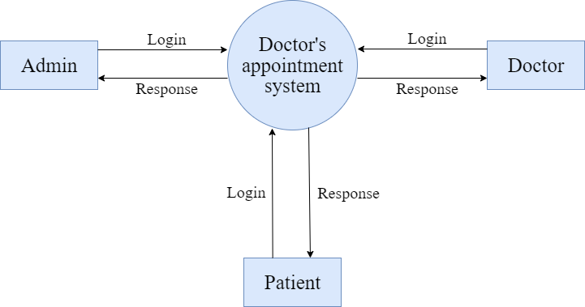

Figure [1]: - CONTEXT LEVEL [DATA FLOW DAIGRAM]

* **DFD: - LEVEL-1 [ADMIN]**

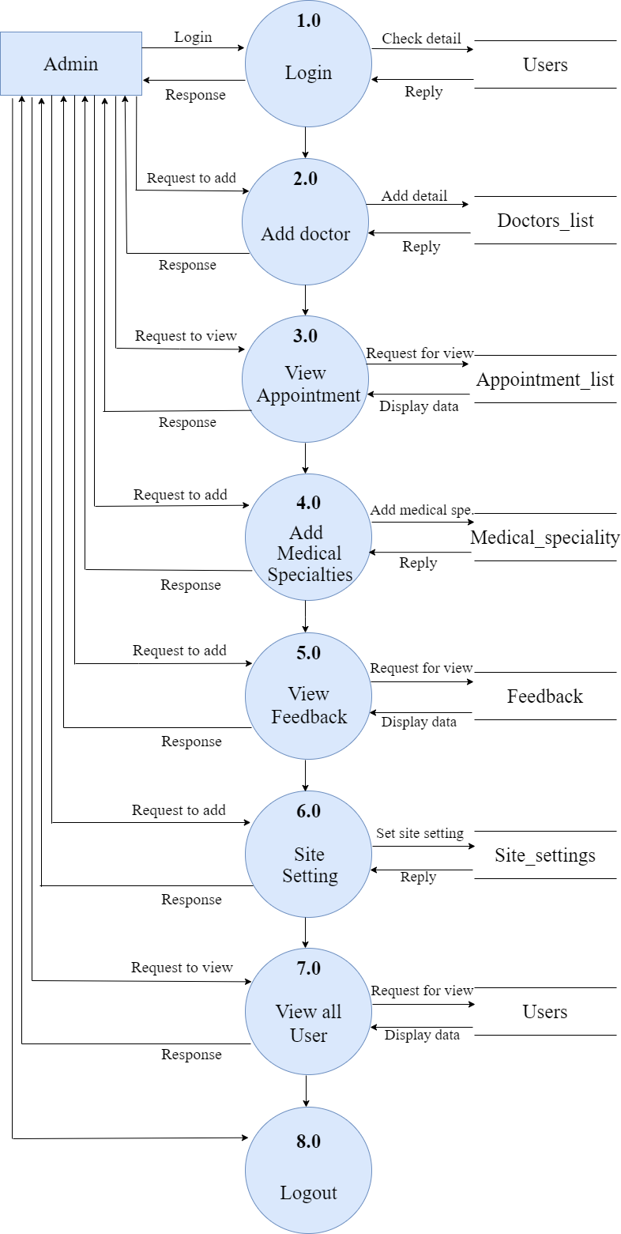

Figure [2]: - LEVEL - 1 [ADMIN]

* **DFD: - LEVEL-1 [DOCTOR]**

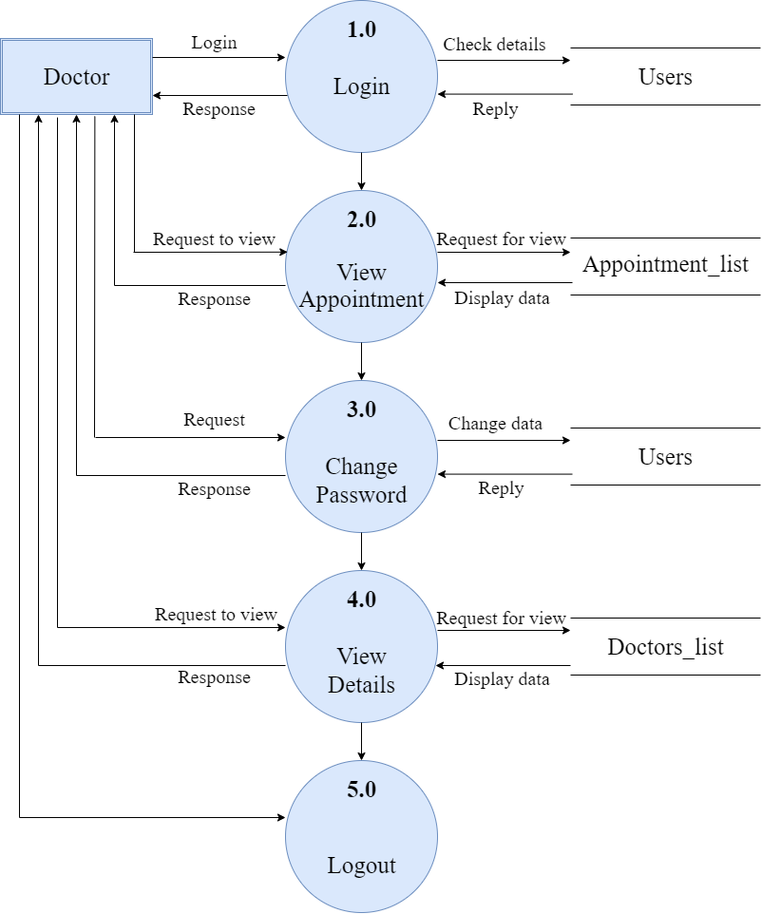

Figure [3]: - LEVEL - 1 [DOCTOR]

* **DFD: - LEVEL-1 [PATIENT]**

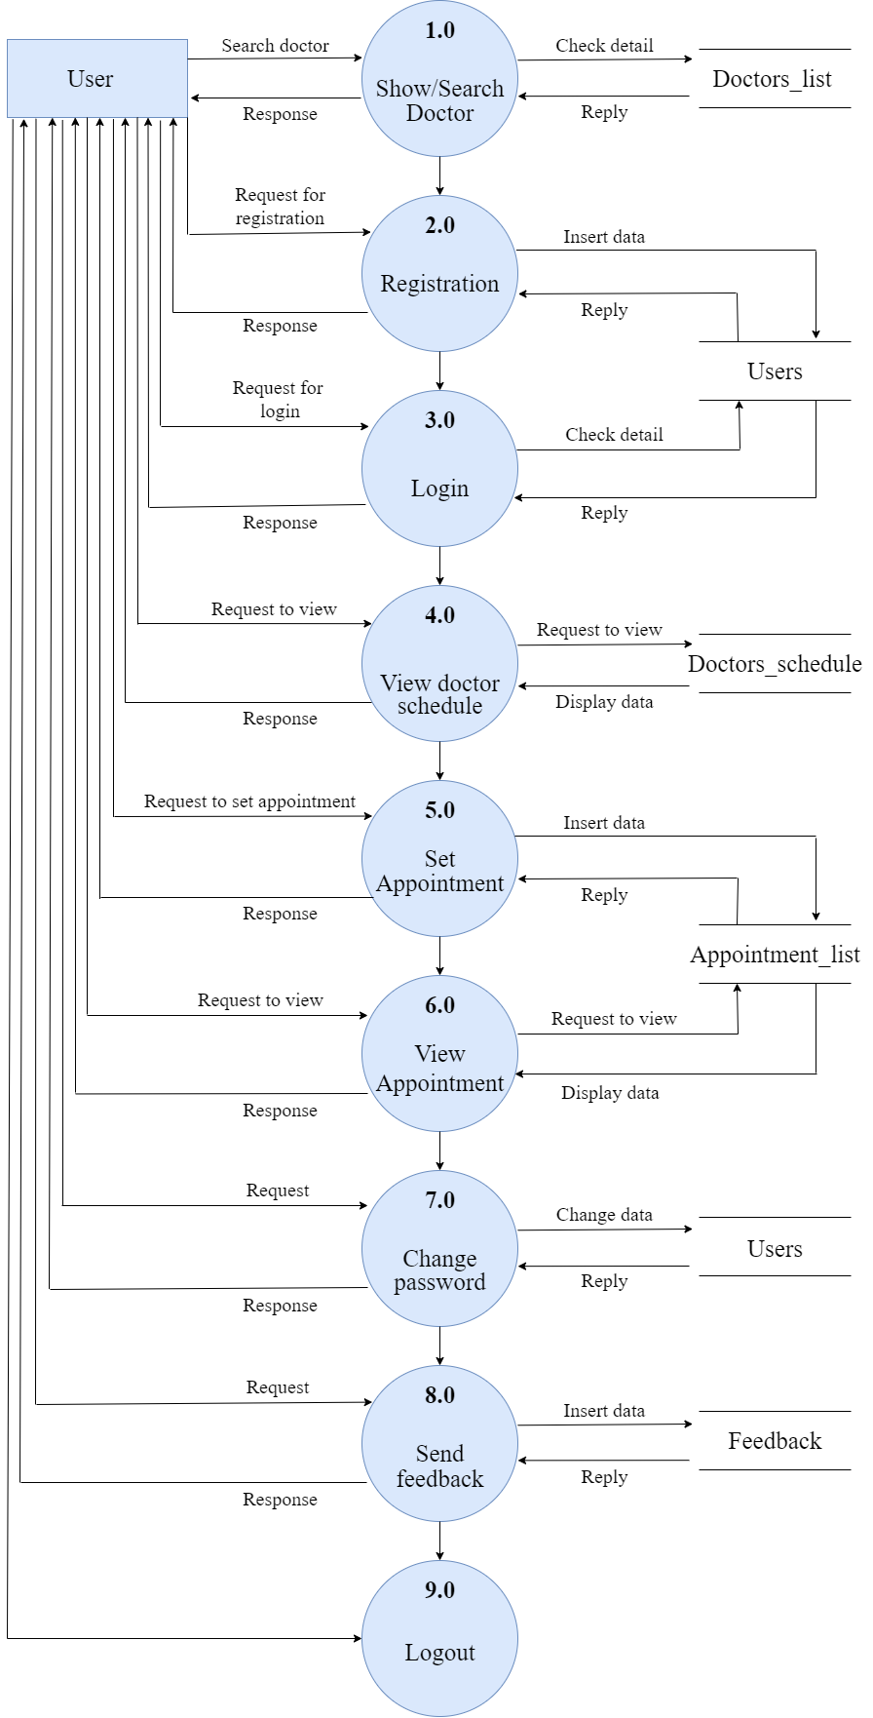

Figure [4]: - LEVEL - 1 [PATIENT]

* **DFD: LEVEL-2 [ADMIN]**
* **ADMIN SIDE [2.0]: -**

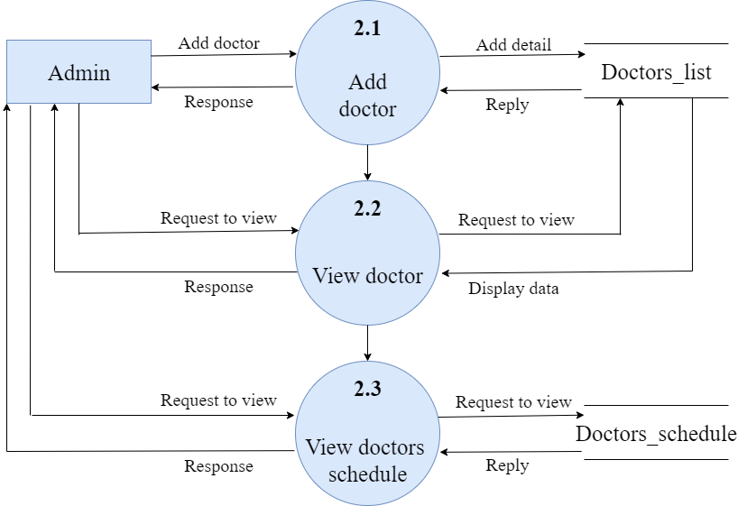

Figure [5]: - LEVEL - 2 [ADMIN 2.0]

* **ADMIN SIDE [3.0]: -**

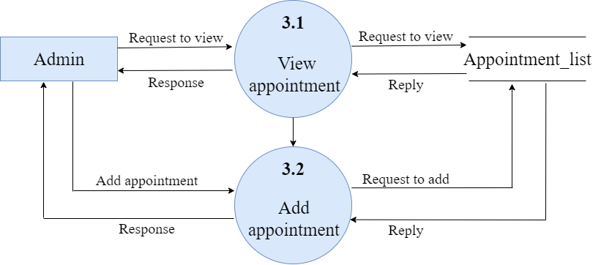

Figure [6]: - LEVEL - 2 [ADMIN 3.0]

* **ADMIN SIDE [4.0]: -**

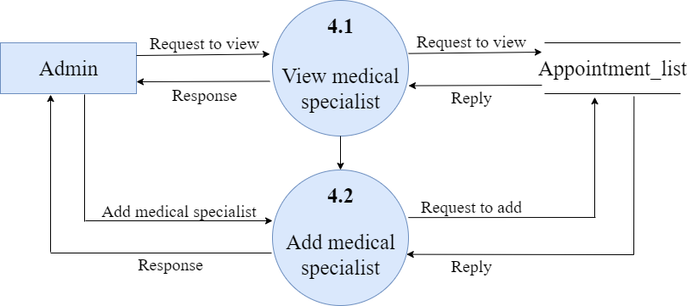

Figure [7]: - LEVEL - 2 [ADMIN 4.0]

* **ADMIN SIDE [7.0]: -**

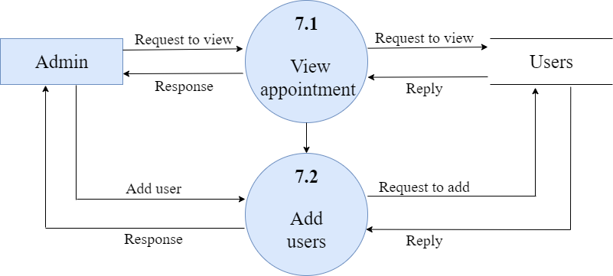

Figure [8]: - LEVEL - 2 [ADMIN 7.0]

* **DFD: LEVEL-2 [DOCTOR]**
* **DOCTOR SIDE [2.0]**

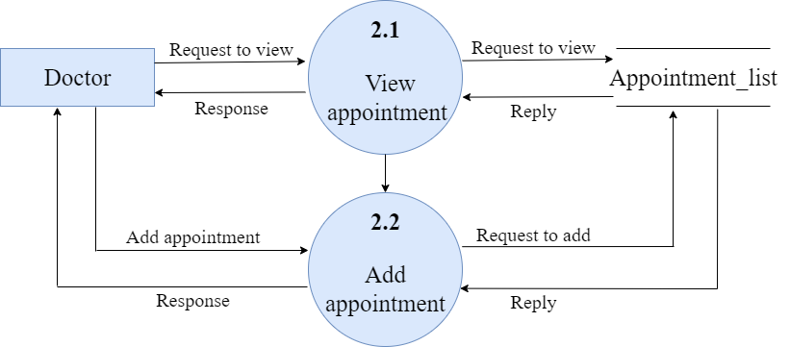

Figure [9]: - LEVEL - 2 [DOCTOR 2.0]

* **DFD: LEVEL-2 [PATIENT]**
* **PATIENT SIDE [6.0]**

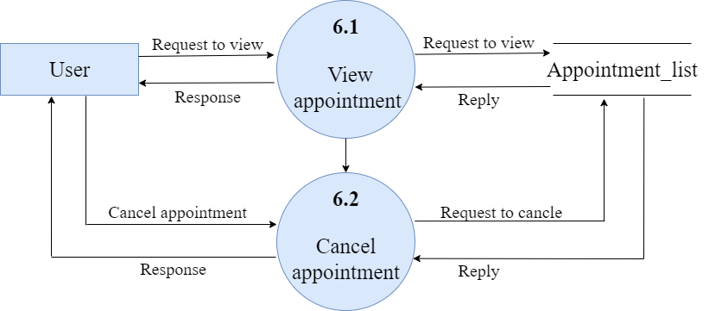

Figure [10]: - LEVEL - 2 [PATIENT 6.0]

3.4 E- R DAIGRAM

1. Entity Relationship Diagram, also known as ER diagram or ER model, is a type of structural diagram for use in database design.
2. An ERD contains different symbols and connectors that visualize two important information: The major entities within the system scope, and the inter-relationships among these entities.
3. An Entity Relationship (ER) Diagram is a type of flowchart that illustrates how “entities” such as people, objects or concepts relate to each other within a system.
4. ER diagrams also are often used in conjunction with dataflow diagrams (DFDs), which map out the flow of information for processes or systems.
5. Let us of learn how the ER model is represented by means of ER diagram. Any object for example, entities, relationship sets, and attributes of relationship of sets, can be represented with the help of an ER diagram.
6. An entity-relationship diagram (ERD) is crucial to creating a good database design. A relationship is the association that describes the interaction between entities.

1. Cardinality, in the context of ERD, is the number of instances of one entity that can, or must, be associated with each instance of another entity.
2. In general, there may be one-to-one, one-to-many, or many-to-many relationships. Here, are prime reasons for using the ER Diagram Helps you to define terms related to entity relationship modelling Provide a preview of how all your tables should connect, what fields are going to be on each table.
3. Helps to describe entities, attributes, relationships .ER diagrams are translatable into relational tables which allows you to build databases quickly .ER diagrams can be used by database designers as a blueprint for implementing data in specific software applications.
4. The database designer gains a better understanding of the information to be contained in the database with the help of ERP diagram. ERD is allowed you to communicate with the logical structure of the database to users.

* **E-R DIAGRAM: -**

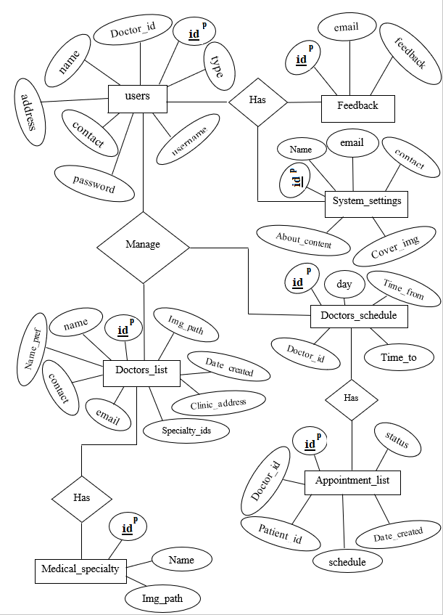

Figure [11]: - ENTITY-RELATIONSHIP DAIGRAM

3.5 DATA DICTIONARY

* **What is Data Dictionary?**

1. A data dictionary contains metadata i.e., data about the database. The data dictionary is very important as it contains information such as what is in the database, who is allowed to access it, where is the database physically stored etc.
2. The users of the database normally don't interact with the data dictionary, it is only handled by the database administrators.

* **Importance of Data Dictionary: -**

1. To communicate a common meaning for all system elements.
2. To document the features of the system. - To facilitate analysis of the details on order to evaluate characteristics and determine where system changes should be made.
3. There is a style of data dictionaries known as a middleware data dictionary. - Middleware is computer software that connects software components or applications. The software consists of a set of services that allows multiple processes running on one or more machines to interact.
4. Traditional data dictionaries provide structure and basic function to the database. Middleware data dictionaries are located within the DBMS itself and operate on a higher level. Middleware data dictionaries can provide alternate entity relationship structures that can be tailored to fit different users that interact with the same database.
5. Middleware data dictionaries can also assist in query optimization as well as distributed database.
6. Middle wear also helps database designer by reducing the amount of time it. takes to create form, queries, reports, menu and many other database components. they do this by automatically generated SQL code for common item such as forms and views.

* **TABLE 1: - medical_specialty**
* In this table store the categories of medical like orthopedic, cardiology, dentist etc.,

|  |  |  |  |  |  |
| --- | --- | --- | --- | --- | --- |
| Sr no. | Field Name | Data Type | Size | Constrain | Description |
| 1 | id | int | 5 | Primary key | Id of Medical  specialties |
| 2 | name | text | 30 | Not null | Name of  Medical  specialties |
| 3 | img_path | text | 90 | Not null | Image path  For Medical  specialties |

* **TABLE 2: - doctors_schedule**
* In this table contain the information the information of schedule starting time and also ending time.
* In this table all information about to doctor’s schedule to describe in below: -

|  |  |  |  |  |  |
| --- | --- | --- | --- | --- | --- |
| Sr no. | Field Name | Data Type | Size | Constrain | Description |
| 1 | id | int | 5 | Primary key | Id of schedule |
| 2 | doctor_id | text | 5 | Not null | Id of doctor |
| 3 | day | text | 10 | Not null | Day of week |
| 4 | time_from | time | - | Not null | Start time of  schedule |
| 5 | time_to | time | - | Not null | End time of  schedule |

* **TABLE 3: - feedback**
* feedback table take review from end users. In this table contains about user such as id, email, feedback etc., to describe in below table: -

|  |  |  |  |  |  |
| --- | --- | --- | --- | --- | --- |
| Sr no. | Field Name | Data Type | Size | Constrain | Description |
| 1 | id | int | 5 | Primary key | Id of feedback |
| 2 | email | varchar | 30 | Not null | E-mail id of  end user |
| 3 | feedback | varchar | 200 | Not null | Review from  user |

* **TABLE 4: - doctors_list**
* In this table store the detail of doctor’s information such as id, name, contact, email,

address etc., to describe in below: -

|  |  |  |  |  |  |
| --- | --- | --- | --- | --- | --- |
| Sr no. | Field Name | Data Type | Size | Constrain | Description |
| 1 | id | int | 5 | Primary key | Id of doctor |
| 2 | name | varchar | 30 | Not null | Name of doctor |
| 3 | name_pref | varchar | 5 | Not null | Prefix of doctor |
| 4 | clinic_address | varchar | 35 | Not null | Address of  clinic |
| 5 | contact | varchar | 14 | Not null | Contact of  doctor |
| 6 | email | varchar | 30 | Not null | E-mail of  doctor |
| 7 | specialty_ids | text | 10 | Not null | Id of medical  specialties |
| 8 | img_path | varchar | 90 | Not null | Path of doctor  image |
| 9 | date_created | datetime | - | Not null | Date when  doctor account  is created |

* **TABLE 5: - appointment_list**
* In appointment list table that store doctor id, patient id, date and time of appointment,

date when patient take appointment of doctor.

|  |  |  |  |  |  |
| --- | --- | --- | --- | --- | --- |
| Sr no. | Field Name | Data Type | Size | Constrain | Description |
| 1 | id | int | 5 | Primary key | Id of  appointment |
| 2 | doctor_id | int | 5 | Not null | Id of doctor |
| 3 | patient_id | int | 5 | Not null | Id of  patient |
| 4 | schedule | datetime | - | Not null | Date and time  of patient  appointment |
| 5 | status | tinyint | 1 | Not null | 0 = pending  request,  1 = confirm,  2 = reschedule,  3 = cancle |
| 6 | date_created | datetime | - | Not null | Date when  patient take  appointment  of doctor |

* **TABLE 6: - users**
* Users table that stores all users information like name, username, password, type.
* it stores admin, doctor and also end users information.

|  |  |  |  |  |  |
| --- | --- | --- | --- | --- | --- |
| Sr no. | Field Name | Data Type | Size | Constrain | Description |
| 1 | id | int | 5 | Primary key | Id of user |
| 2 | doctor_id | int | 5 | Not null | Id of doctor |
| 3 | name | varchar | 30 | Not null | Name of user |
| 4 | address | varchar | 35 | Not null | Address of user |
| 5 | contact | varchar | 14 | Not null | Contact of user |
| 6 | username | varchar | 20 | Not null | Username of  user |
| 7 | password | varchar | 10 | Not null | Password of  user |
| 8 | type | tinyint | 1 | Not null | 1 = admin,  2 = doctor,  3 = end user  [patient] |

* **TABLE 7: - system_settings**
* In system setting table store mail of system, contact of system and also content about us of the system.

|  |  |  |  |  |  |
| --- | --- | --- | --- | --- | --- |
| Sr no. | Field Name | Data Type | Size | Constrain | Description |
| 1 | id | int | 5 | Primary key | Id of system  setting |
| 2 | name | varchar | 30 | Not null | Name of the  system |
| 3 | email | varchar | 30 | Not null | E-mail for  contact & user |
| 4 | contact | varchar | 14 | Not null | Contact of  end user |
| 5 | cover_img | text | 30 | Not null | Image path of  cover image |
| 6 | about_content | text | 900 | Not null | Content of  about page |

3.6 INPUT-OUTPUT DESIGN

* ADMIN LEVEL MODULES: -
* Login page: -

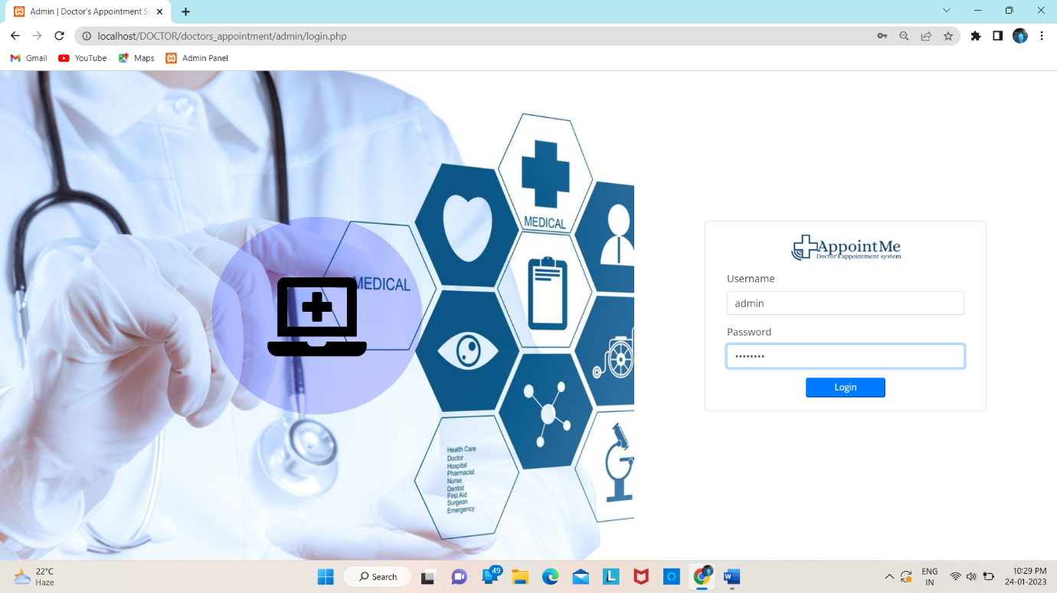

Figure [12]: - Admin Login Page

* Description: -

1. Admin login in doctor’s appointment System to update or delete the appointment.
2. Admin login to manage all System Information.
3. All user and doctor Details and Information.

* Dashboard Page: -

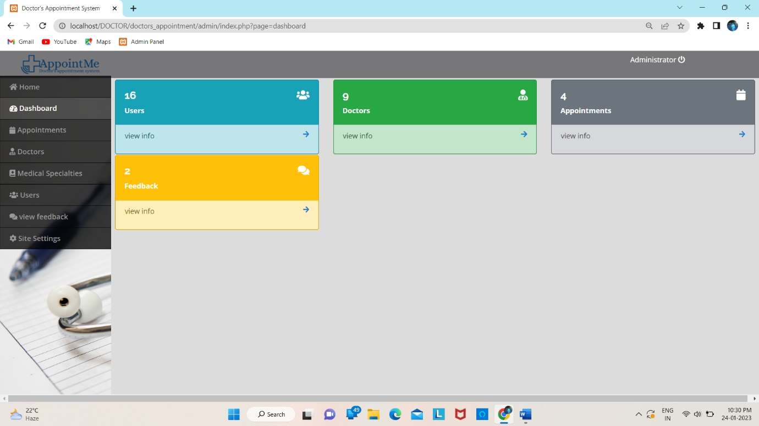

Figure [13]: - Dashboard Page

* Description: -

1. In dashboard page that display all information of doctor’s appointment system such as total number of users, doctor, appointment and also feedback.
2. Admin can also view specific pages from this page by click on arrow.

* Add doctor: -

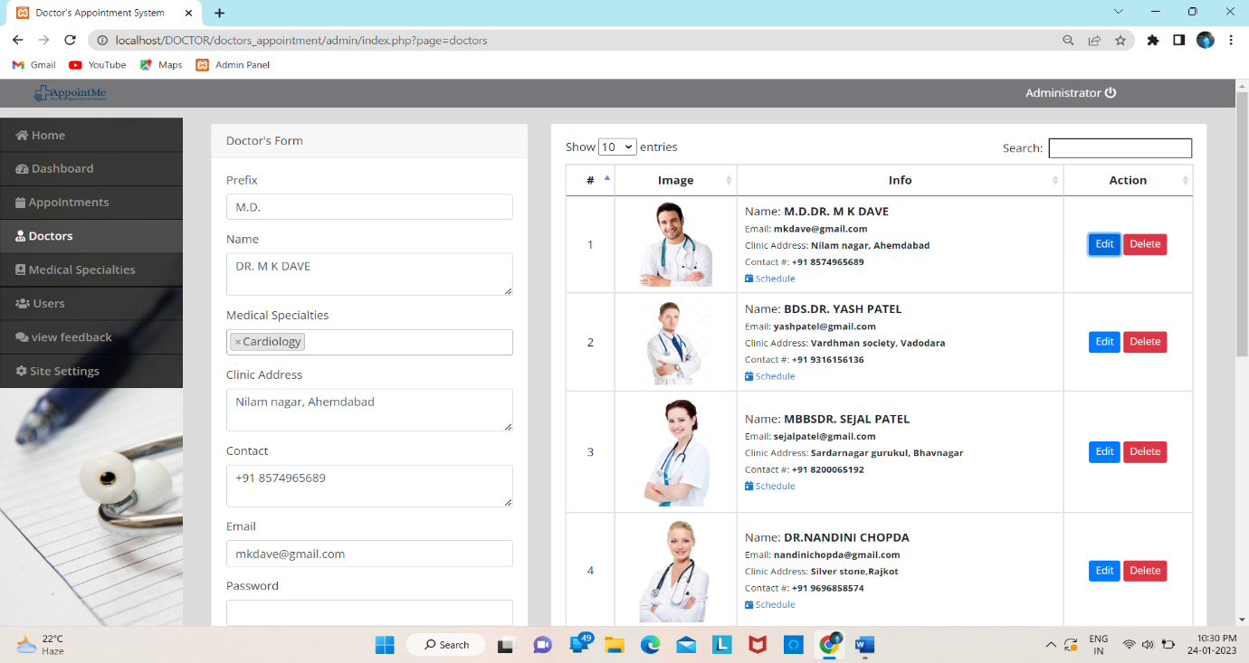

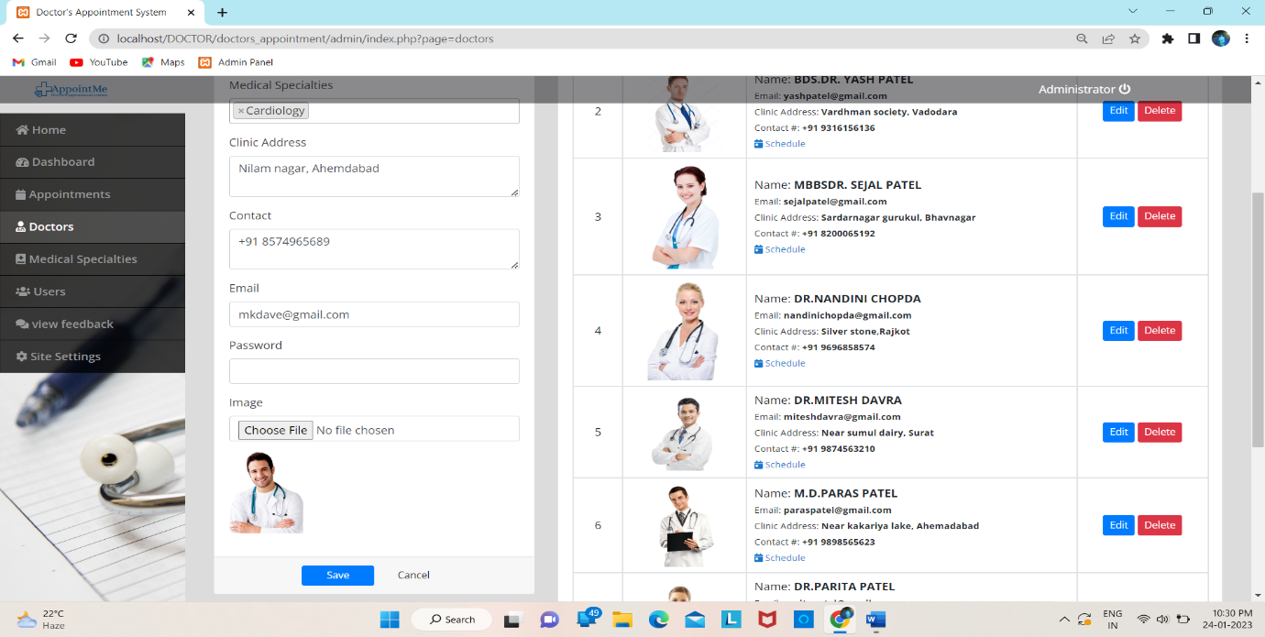Figure [14]: - Add doctor

* Description: -

1. Admin can add, update, delete doctor information like name, address, specialty, email and password etc.,

* Add Medical specialties: -

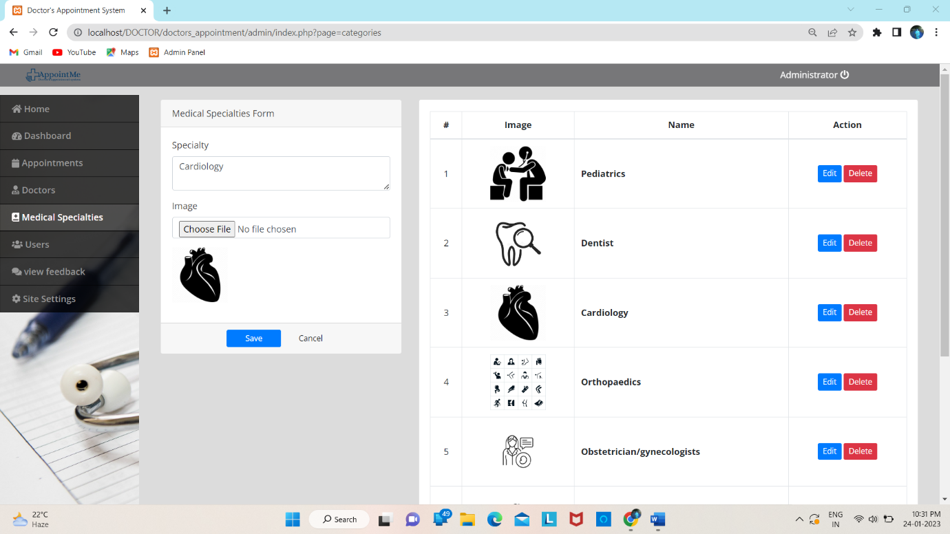

Figure [15]: - Add Medical specialties

* Description: -

1. Medical specialties in doctor’s appointment system that add, update or delete medical specialty like cardiology, audiology, dentist etc.,

* System setting page: -

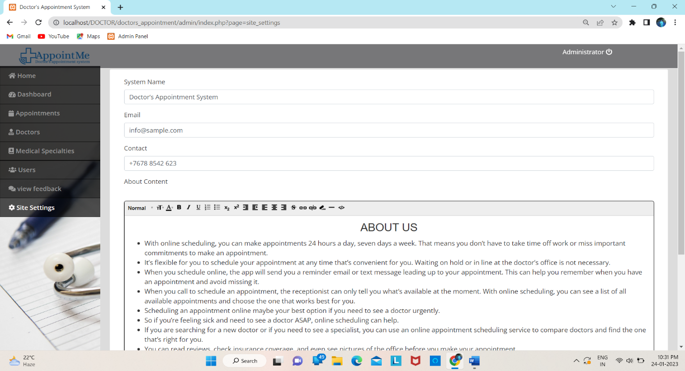

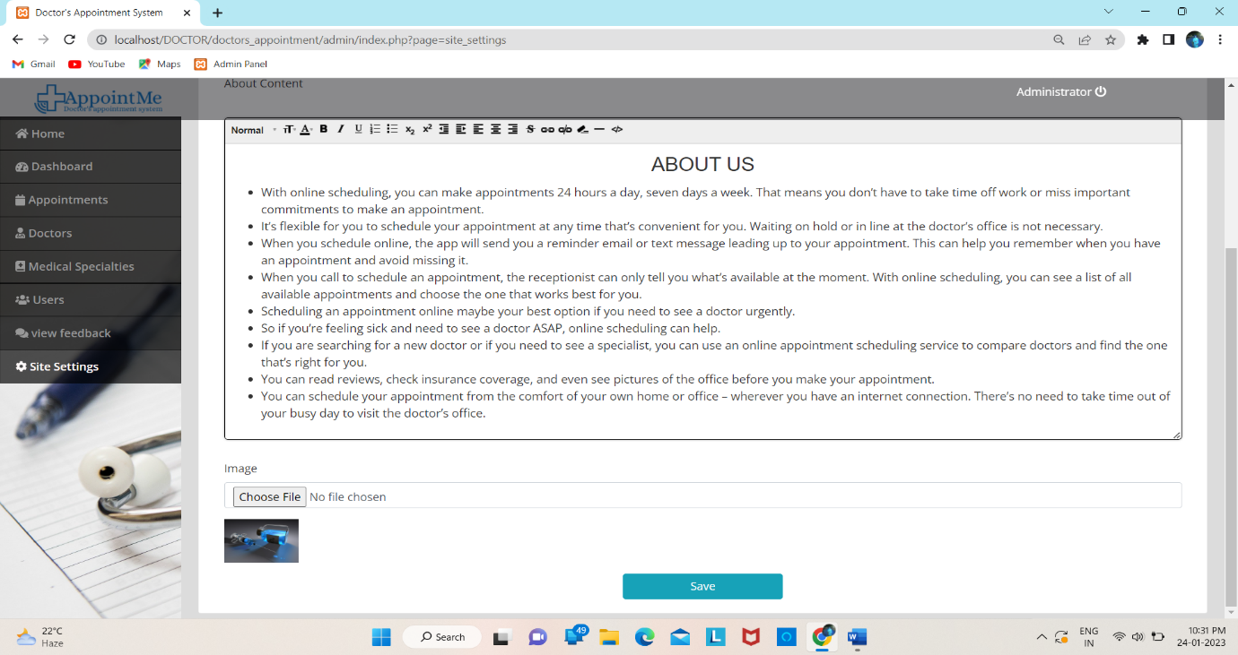Figure [16]: - System setting page

* Description: -

1. In system setting admin can set mail id, contact, about us content of system and also set cover image for user side.

* DOCTOR LEVEL MODULES: -
* Login page: -

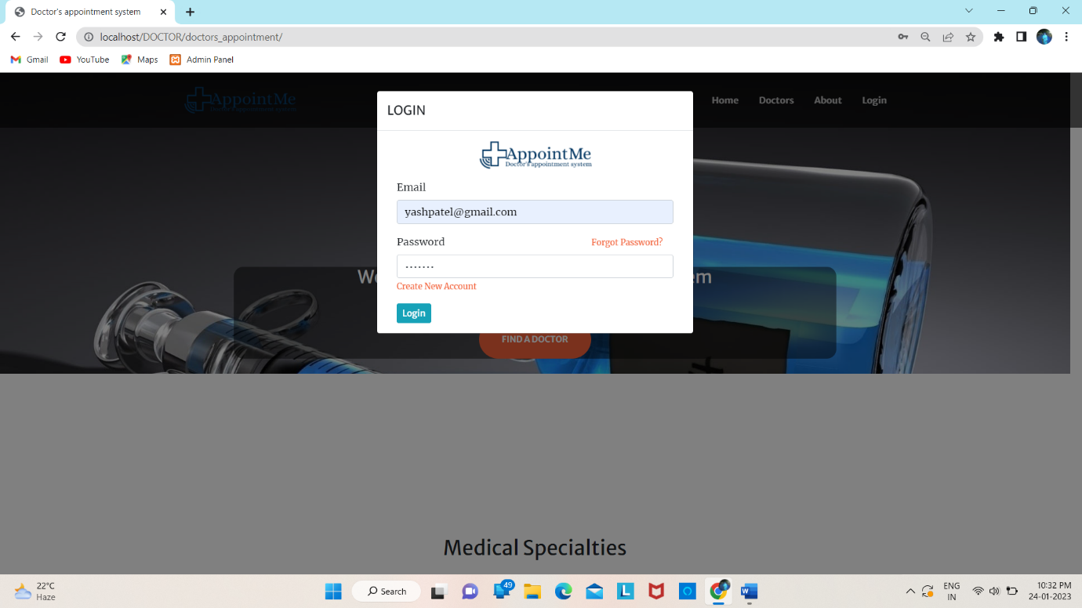

Figure [17]: - Login page

* Description: -

1. In this login page doctor and also patient can log into their side by enter E-mail and its password.
2. When doctor or patient logged into the system, they redirect to their home page.

* Appointment list page: -

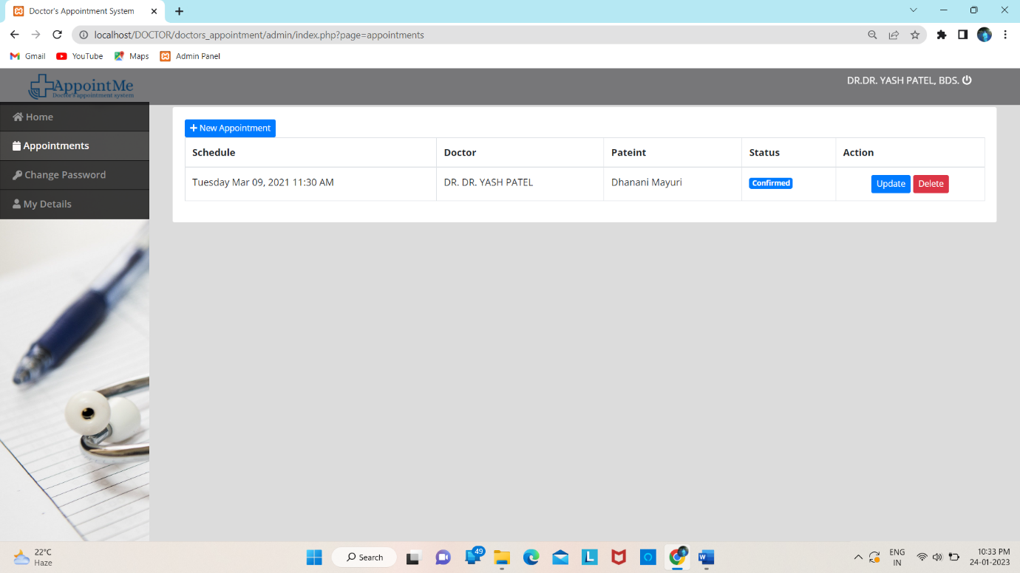

Figure [18]: - Appointment list page

* Description: -

1. In appointment page doctors can view particular appointments taken by patients.
2. Doctors can add new appointment to the list by click on new appointment button and fill up the form. He/she can add new appointment.
3. doctors can cancel, rescheduled or confirm patient or end user request.

* Change password page: -

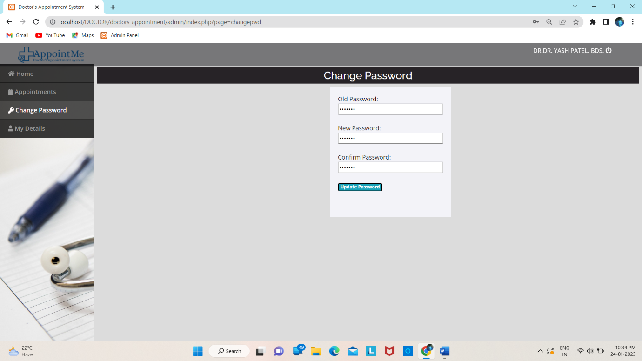

Figure [19]: - Change password page

* Description: -

1. In change password page doctors enter their old password as well as new password and confirm password and new password or confirm password both are same and then click on update button so that doctor can change password.

* Doctor’s details page: -

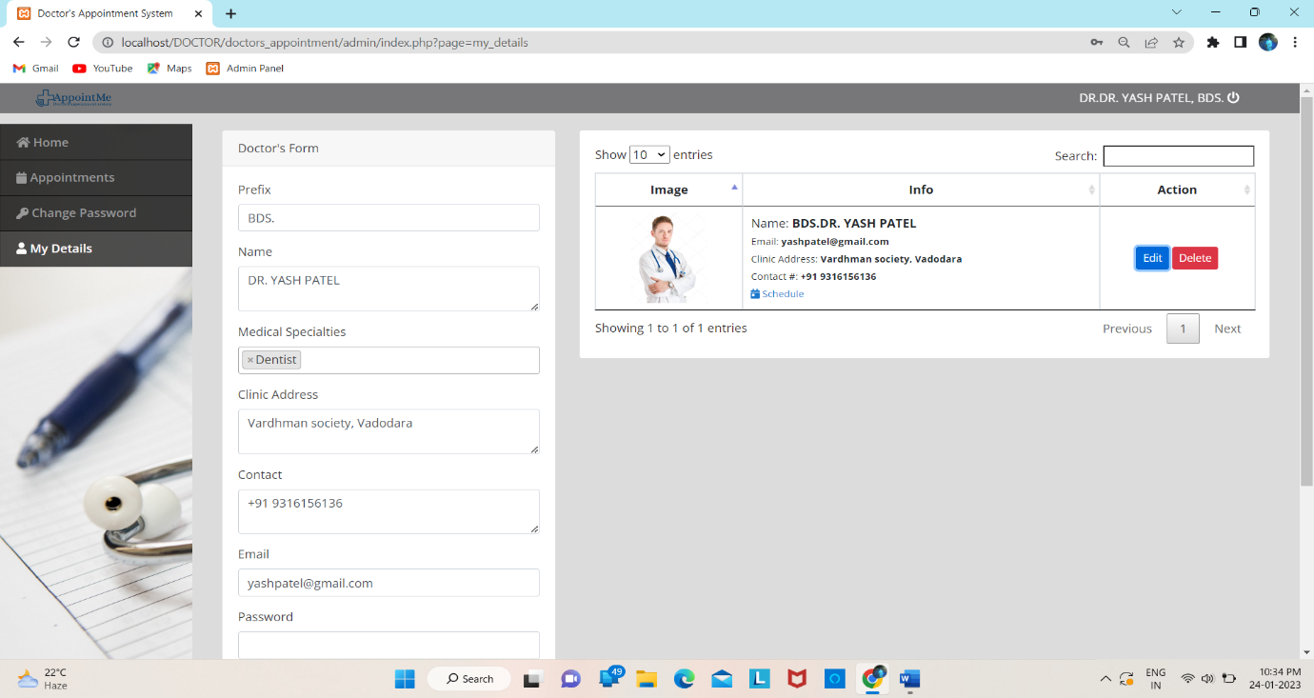

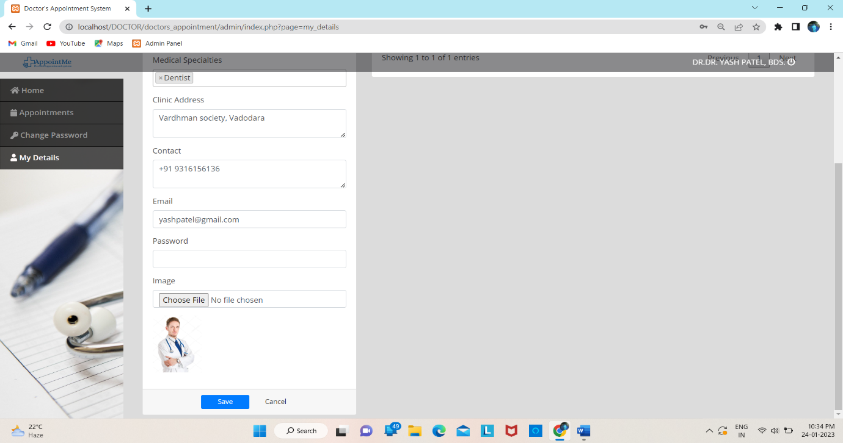Figure [20]: - Doctor’s details page

* Description: -

1. In this page doctors see their detail like name, profile picture, address, mobile number, email id and also schedule etc., he/she also update information by click on update button.

* PATIENT LEVEL MODULES: -
* Registration page: -

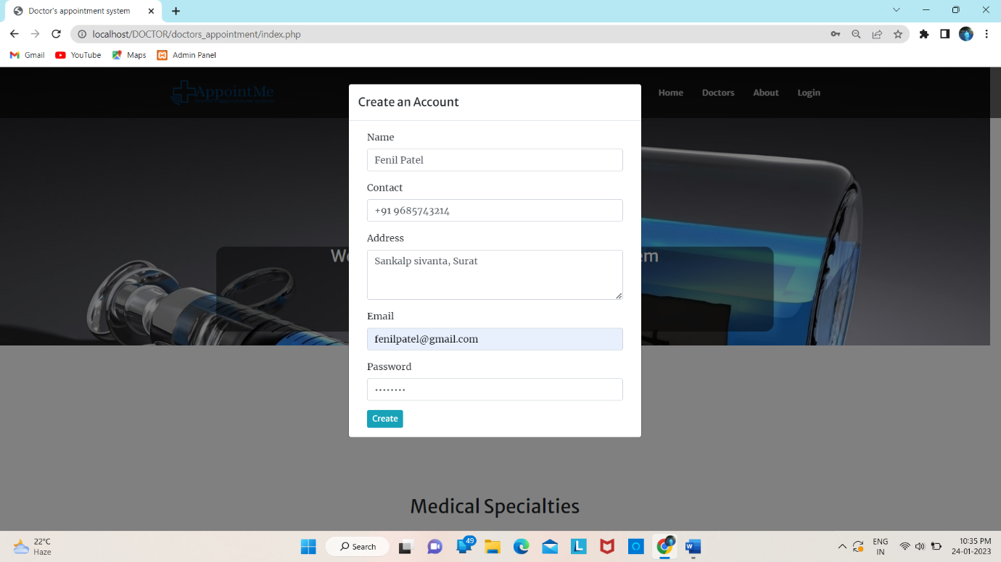

Figure [21]: - Registration page

* Description: -

1. In registration page end user fill up all the information such as name, contact, address, E-mail, password etc., and then click on create button to create a new user of the system.

* Set appointment: -

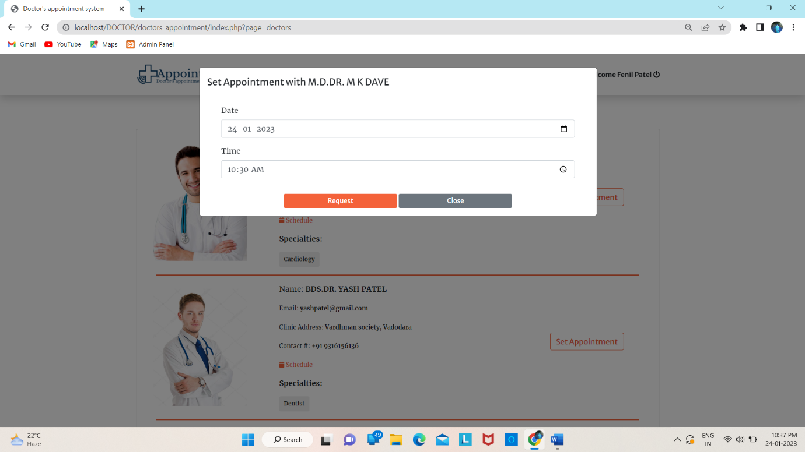

Figure [22]: - Set appointment

* Description: -

1. End user enter date and time according to particular doctor’s schedule and set appointment with doctor as request submit by patient to take appointment to doctor.
2. Only register users can set appointment with doctor. If user not register then first register and then take appointment with doctor.
3. User can take appointment easily according to doctor’s schedule.

* Change password: -

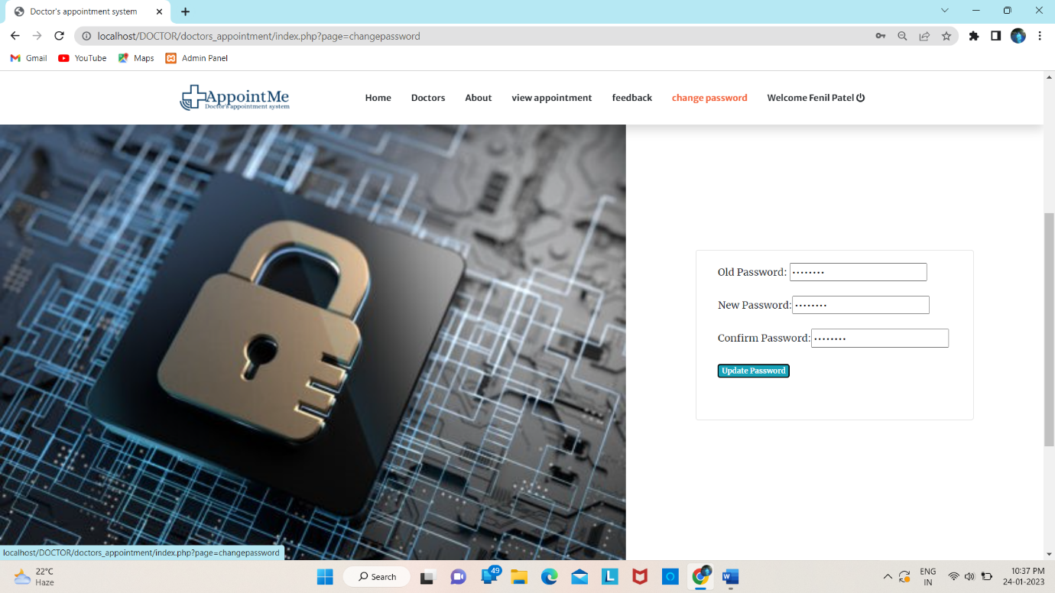

Figure [23]: - Change password

* Description: -

1. In change password page user can be easily to change his/her password.
2. In change password page End users enter their old password as well as new password and confirm password and click on update button so that End user can change password.

CHAPTER: - 4

TESTING

&

IMPLEMENTATION

4.1 TESTING DEFINATION

1. Software testing is nothing but an art of investigating software to ensure that its quality under test is in line with the requirement of the client.
2. Software testing is carried out in a systematic manner with the intent of finding defects in a system. It is required for evaluating the system.
3. As the technology is advancing, we see that everything is getting digitized. You can access your bank online, you can shop from the comfort of your home, and the options are endless.
4. Have you ever wondered what would happen if these systems turn out to be defective? One small defect can cause a lot of financial loss.
5. It is for this reason that software testing is now emerging as a very powerful field in IT.
6. Software testing is defined as an activity to check whether the actual results match the expected results and to ensure that the software system is Defect free. It involves execution of a software component or system component to evaluate one or more properties of interest.
7. Software testing also helps to identify errors, gaps or missing requirements in contrary to the actual requirements. It can be either done manually or using automated tools. Some prefer saying Software testing as a White Box and Black Box Testing.

* **So, to summarize we can say that: -**

1. Software testing is required to check the reliability of the software.
2. Software testing ensures that the system is free from any bug that can cause any kind of failure.
3. Software testing ensures that the product is in line with the requirement of the client.
4. It is required to make sure that the final product is user friendly.
5. At the end software is developed by a team of human developers all having different viewpoints and approach. Even the smartest person has the tendency to make an error. It is not possible to create software with zero defects without incorporating software testing in the development cycle.
6. No matter how well the software design looks on paper, once the development starts and you start testing the product you will definitely find lots of defects in the design.

4.2 TESTING PLAN

1. Test planning, the most important activity to ensure that there is initially a list of tasks and milestones in a baseline plan to track the progress of the project. It also defines the size of the test effort.
2. It is the main document often called as master test plan or a project test plan and usually developed during the early phase of the project.
3. A TEST PLAN is a document describing software testing scope and activities. It is the basis for formally testing any software/product in a project.

* **Test plan: -**

1. A document describing the scope, approach, resources and schedule of intended test activities.
2. It identifies amongst others test items, the features to be tested, the testing tasks, who will do each task, degree of tester independence, the test environment, the test design techniques and entry and exit criteria to be used, and the rationale for their choice, and any risks requiring contingency planning.
3. It is a record of the test planning process.

* **Master test plan: -**
* A test plan that typically addresses multiple test levels.
* **Phase test plan: -**
* A test plan that typically addresses one test phase.

4.3 TESTING APPROCH

**[1] Unit testing – Module Testing: -**

* Testing of an individual software component or module is termed as Unit Testing. It is typically done by the programmer and not by testers, as it requires a detailed knowledge of the internal program design and code. It may also require developing test drive modules or test harnesses.

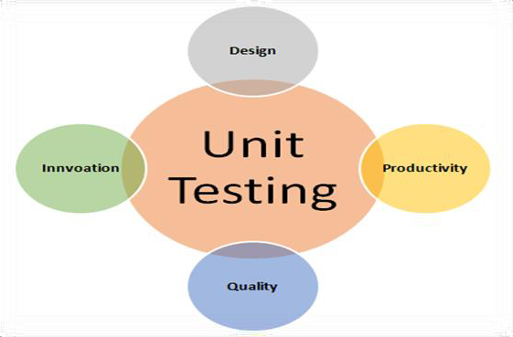

Figure [1]: - [Unit Testing]

**[2] Integration Testing: -**

* Testing of all integrated modules to verify the combined functionality after integration is termed as Integration Testing. Modules are typically code modules, individual applications, client and server applications on a network, etc.

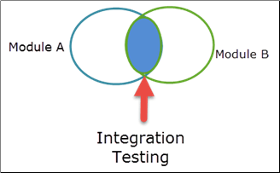

Figure [2]: - [Integration Testing]

**[3] Acceptance Testing: -**

* An acceptance test is performed by the client and verifies whether the end to end the flow of the system is as per the business requirements or not and if it is as per the needs of the end user. Client accepts the software only when all the features and functionalities work as expected.

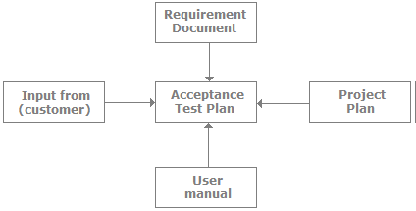

Figure [3]: - [Acceptance Testing]

**[4] Software Testing: -**

* Involves executing an implementation of the software with test data and examining the outputs of the software and its operational behavior to check that it is performing as required.

**[5] System Testing: -**

* Under System Testing technique, the entire system is tested as per the requirements. It is a Black-box type testing that is based on overall requirement specifications and covers all the combined parts of a system.

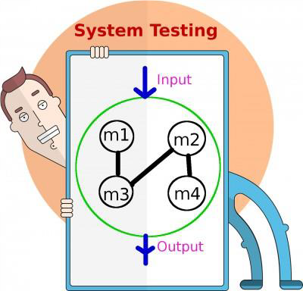

Figure [4]: - [System Testing]

**[6] Smoke Testing: -**

* Smoke testing is an integration testing approach that is commonly used when product software is developed. It is designed as a pacing mechanism for time-critical projects allowing the software team to assess the project on a frequent basis.

**[7] Black-Box Testing: -**

* Black box testing is a technique of software testing which examines the functionality of software without peering into its internal structure or coding. The primary source of black box testing is a specification of requirements that is stated by the customer.
* In this method, tester selects a function and gives input value to examine its functionality, and checks whether the function is giving expected output or not. If the function produces correct output, then it is passed in testing, otherwise failed.



Figure [5]: - [Black-Box Testing]

**[8] White-Box Testing: -**

* The box testing approach of software testing consists of black box testing and white box testing. We are discussing here white box testing which also known as glass box is testing, structural testing, clear box testing, open box testing and transparent box testing. It tests internal coding and infrastructure of a software focus on checking of predefined inputs against expected and desired outputs.
* It is based on inner workings of an application and revolves around internal structure testing. In this type of testing programming skills are required to design test cases.
* The primary goal of white box testing is to focus on the flow of inputs and outputs through the software and strengthening the security of the software.

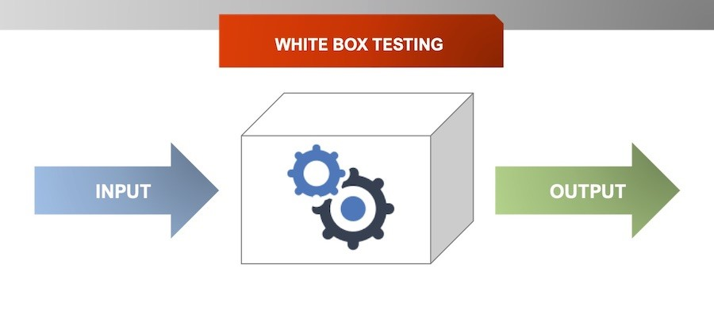

Figure [6]: - [White-Box Testing]

**[9] Grey-Box Testing: -**

* Grey Box Testing or Gray box testing is a software testing technique to test a software product or application with partial knowledge of internal structure of the application. The purpose of grey box testing is to search and identify the defects due to improper code structure or improper use of applications.
* In this process, context-specific errors that are related to web systems are commonly identified. It increases the testing coverage by concentrating on all of the layers of any complex system.



Figure [7]: - [Grey-Box Testing]

4.4 TEST CASE

* **Test case: - [1]**

|  |  |
| --- | --- |
| Test Case id | 1 |
| Name | Valid backend Admin login to enter his Username and Password. |
| Description | This test case will check and allow administrator to log-in to system / the backend of system. |
| Input Data | 1. Enter valid Username. 2. Enter valid Password. |
| Test Data | Username = admin  Password = admin123 |
| Expected Output | System needs to check if username and password is valid into system MySQL database: -  Case 1: If username and password are match and found from database then allow to access system (by forwarding to Home screen).  Case 2: If username and password does not match in database then give message “username or password is incorrect”. |
| Actual Output | System Allows admin to login because Username and Password is correct. |
| Pass / Fail | PASS |

* **Test case: - [2]**

|  |  |
| --- | --- |
| Test Case id | 2 |
| Name | Valid doctor detail. |
| Description | This test case will allow to make sure to add/edit/delete valid doctor detail by logged in user in backend. |
| Input Data | 1. Enter valid doctor prefix. 2. Enter valid doctor name. 3. Select valid medical specialty. 4. Enter valis doctor clinic address. 5. Enter valid contact. 6. Enter valid email address. 7. Enter valid password. 8. Upload valid doctor image. |
| Test Data | Prefix=Dr.,  Name=abc,  Medical specialty=cardiology,  Address=gabani chowk, vallabhipur,  Contact=+91 9316156136,  [Email=abc@gmail.com](mailto:Email=abc@gmail.com),  Password=abc123. |
| Expected Output | Admin fill-up doctor information and click on save button all information display into right side of page also in doctors page of user side, and doctors view their particular information and also edit it. |
| Actual Output | System allow user to store detail into system database. |
| Pass / Fail | PASS |

* **Test case: - [3]**

|  |  |
| --- | --- |
| Test Case id | 3 |
| Name | Valid medical specialty detail. |
| Description | This test case will allow to make sure to add/edit/delete valid medical specialty type by logged in user in backend. |
| Input Data | 1. Enter specialty name. 2. Upload specialty image. |
| Test Data | Specialty Name = Cardiology |
| Expected Output | Medical specialty name is compulsory/required.  Image can be optional.   * Admin fill-up medical specialty information and click on save button all information display into right side of page also in home page of user side. System allow user to store detail into system database. |
| Actual Output | System allows to store medical specialty detail into system database. |
| Pass / Fail | PASS |

* **Test case: - [4]**

|  |  |
| --- | --- |
| Test Case id | 4 |
| Name | Valid doctor schedule. |
| Description | This test case will allow to make sure to add/edit valid medical doctor schedule by logged in user in backend. |
| Input Data | 1. Enter weekly time. |
| Test data | Day=Monday,  Time to=8:00 AM,  Time from=5:30 PM. |
| Excepted Output | Schedule is compulsory/required.   * Admin and also doctor add schedule and click on save button schedule display with doctor information also in doctor page of user side. System allow user to store schedule into system database. |
| Actual Output | System allows to store doctors schedule detail into system database. |
| Pass/Fail | PASS |

* **Test case: - [5]**

|  |  |
| --- | --- |
| Test Case id | 5 |
| Name | Valid doctor user. |
| Description | This test case will allow to make sure to add/edit/delete user by logged in user in backend. |
| Input Data | 1. Enter valid name. 2. Enter valid username. 3. Enter valid password. 4. Select valid type of user. |
| Test Data | Name = abc,  [Username=abc@gmail.com](mailto:Username=abc@gmail.com),  Password=abc123,  Type = end user. |
| Expected Output | All fields are compulsory/required.  Admin add/edit/delete user and click on save button information store into database and user successfully login to system. |
| Actual Output | System allow user to store detail into system database. |
| Pass / Fail | PASS |

* **Test case: - [6]**

|  |  |
| --- | --- |
| Test Case id | 6 |
| Name | Add valid appointment. |
| Description | This test case will allow to make sure to add/edit/delete appointment by logged in user in backend. |
| Input Data | 1. Select valid doctor name. 2. Select valid patient name. 3. Select valid date and time for appointment. 4. Select valid status for appointment. |
| Test data | Doctor name=Dr.abc,  Patient name=Xyz,  Date and time=Wednesday may 12,2021 3:30 PM,  Status = confirm. |
| Excepted Output | All fields are compulsory/required.   * Admin add/edit/delete appointment and click on save button information store into database and also display on admin side and particular doctor and patient side. * Only registered doctors and patients select in new appointment form. * Doctor add/edit/delete appointment and click on save button information store into database and also display on admin side and particular patient side. Doctor select patient name, date time and status. |
| Actual Output | System allows to store Add Valid Appointments details into system database. |
| Pass/Fail | PASS |

* **Test case: - [7]**

|  |  |
| --- | --- |
| Test Case id | 7 |
| Name | Add valid site settings. |
| Description | This test case will allow to make sure to add site settings by logged in user in backend. |
| Input Data | 1. Enter valid system name. 2. Enter valid contact. 3. Enter valid email address. 4. Write about us content. 5. Upload cover image for user side. |
| Test data | System name = doctor’s appointment system,  Contact = +6444 7596 1002,  [Email = AppointMe@gmail.com](mailto:Email%20=%20AppointMe@gmail.com) |
| Excepted Output | All fields are compulsory/required.  Image can be optional.  Case 1: admin add site setting and click on save button information store into database and display in about us and contact us page of user side.. |
| Actual Output | System allows to store site setting info details into system database. |
| Pass/Fail | PASS |

* **Test case: - [8]**

|  |  |
| --- | --- |
| Test Case id | 8 |
| Name | Valid Logout from doctor’s appointment System Backend. |
| Description | This case will allow user to sign-out/log-out from doctor’s appointment backend system. |
| Input Data | 1. go to the top right side and click on username. |
| Test data | - |
| Excepted Output | Admin can click on top right side it will redirect to login page. |
| Actual Output | System allows to admin can logout his profile. |
| Pass/Fail | PASS |

* **Test case: - [9]**

|  |  |
| --- | --- |
| Test Case id | 9 |
| Name | Valid Backend Change password. |
| Description | This test case will check and allow doctor and end user to change password to system doctor and end user / the backend of system. |
| Input Data | 1. Enter old password. 2. Enter new password. 3. Enter confirm password. |
| Test data | Old password = abc123,  New password = abc2931,  Confirm password = abc2931. |
| Excepted Output | System needs to check if old password is valid into system MySQL database   * Case 1: If old password is match and found from database then allow to change password give message “password has been updated”. * Case 2: If old password does not match in database, then give message “Input correct password”. * Case 3: if new password and confirm password does not match then give message “password did not match”. |
| Actual Output | System allow user to change password into system database. |
| Pass/Fail | PASS |

* **Test case: - [10]**

|  |  |
| --- | --- |
| Test Case id | 10 |
| Name | Valid Backend End user/patient login And Doctor login. |
| Description | This test case will check and allow End user and doctor to log-in to system / the backend of system. |
| Input Data | 1. Enter valid username. 2. Enter valid password. |
| Test data | [Username=abc2931@gmail.com](mailto:Username=abc2931@gmail.com)  Password=abc2931 |
| Excepted Output | System needs to check if username and password is valid into system MySQL database.   * Case 1: If username and password are match and found from database then allow to access system (by forwarding to Home screen and also display feedback, change password and view appointment page). * Case 2: If username and password does not match in database then give message “username or password is incorrect”. (Only display home, doctors, about, admin and login page) |
| Actual Output | System Allows End user/patient and doctor to login because Username and Password is correct. |
| Pass/Fail | PASS |

* **Test case: - [11]**

|  |  |
| --- | --- |
| Test Case id | 11 |
| Name | Valid Sing-up page |
| Description | This test case will allow user to “request” to access doctor’s appointment system by fill-up Signup form. |
| Input Data | 1.Enter valid name.  2.Enter valid contact.  3.Enter valid address.  4.Enter valid email address.  5.Enter valid password. |
| Test data | Name=abc,  Contact=+91 7004001001,  Address=chitra, Bhavnagar.  [Email=abc@gmail.com](mailto:Email=abc@gmail.com),  Password=abc123. |
| Excepted Output | * All fields are compulsory / require. * Username should be valid * Email should be match to valid email address e.g., [abc@gmail.com](mailto:abc@gmail.com) * Enter valid password. * All information store successfully in system database. * If user fill up valid information then he/she successfully logged-in to system. |
| Actual Output | As expected. |
| Pass/Fail | PASS |

* **Test case: - [12]**

|  |  |
| --- | --- |
| Test Case id | 12 |
| Name | Take valid appointment. |
| Description | This test case will allow to make sure to take/view/delete appointment by logged in user in backend. |
| Input Data | 1.select date and time according to particular doctor schedule.  2.click on request button.  3.request submit successfully. |
| Test data | Date=23/04/2021,  Time=5:00 PM. |
| Excepted Output | All fields are compulsory/required.   * End user can take appointment by entering date and time and click on request button information store into database and also display on admin side and particular doctor and patient side. * Patient can also cancel appointment. It will also cancel on admin and particular doctor side. * only End user/patient can take appointment. * If End user not logged in to system and set appointment with doctor it will display login form. * If End user select date time for appointment is not valid according to the schedule, then display message “appointment schedule not valid for selected doctor’s schedule”. |
| Actual Output | System allows to store Take Valid Appointments details into system database. |
| Pass/Fail | PASS |

* **Test case: - [13]**

|  |  |
| --- | --- |
| Test Case id | 13 |
| Name | Valid feedback page |
| Description | This test case will allow user to send reviews to doctor’s appointment system by fill-up feedback form. |
| Input Data | 1. Enter valid email address. 2. Enter message. |
| Test data | [Email=abc@gmail.com](mailto:Email=abc@gmail.com)  Feedback = your website is amazing. |
| Excepted Output | * All fields are compulsory / require. * Email should be match to valid email address e.g., [abc@gmail.com](mailto:abc@gmail.com) * Only registered user can send the feedback. * If user not logged into the system feedback page not display. * Enter fill up information and click to submit button it display message “thanks for your feedback”. * If user feedback not submitted successfully it display message “There was an error”. * System database store information successfully also display in admin side. |
| Actual Output | As expected. |
| Pass/Fail | PASS |

* **Test case: - [14]**

|  |  |
| --- | --- |
| Test Case id | 14 |
| Name | Valid Logout from doctor’s appointment System Backend. |
| Description | This case will allow End user/patient and doctor to sign-out/log-out from doctor’s appointment backend system. |
| Input Data | 1. go to the top right side and click on username. |
| Test data | - |
| Excepted Output | * End user/patient and doctor click on top right side it will logout to system and display only home, doctors, about, admin and login page. |
| Actual Output | System allows to End user/patient and doctor can logout his profile. |
| Pass/Fail | PASS |

4.5 IMPLEMENTATION APPROCH & IMPLEMENTATION TOOL

**[1]: - XAMPP.**

1. XAMPP is one of the widely used cross-platform web servers, which helps developers to create and test their programs on a local webserver. It was developed by the **Apache Friends**, and its native source code can be revised or modified by the audience.
2. The goal of XAMPP is to build an easy to install distribution for developers to get into the world of Apache. To make it convenient for developers, XAMPP is configured with all features turned on.
3. It consists of **Apache HTTP Server, MariaDB, and interpreter** for the different programming languages like PHP and Perl. It is available in 11 languages and supported by different platforms such as the IA-32 package of Windows & x64 package of macOS and Linux.
4. XAMPP is an abbreviation where **X stands for Cross-Platform, A stands for Apache, M stands for**[***MYSQL***](https://www.javatpoint.com/mysql-tutorial)**, and the Ps stand for PHP and Perl**, respectively. It is an open-source package of web solutions that includes Apache distribution for many servers and command-line executables along with modules such as Apache server, [MariaDB](https://www.javatpoint.com/mariadb-tutorial), PHP, and Perl.
5. XAMPP helps a local host or server to test its website and clients via computers and laptops before releasing it to the main server.
6. XAMPP is used to symbolize the classification of solutions for different technologies. It provides a base for testing of projects based on different technologies through a personal server. XAMPP is an abbreviated form of each alphabet representing each of its major components.

* **Needs For XAMPP: -**
* XAMPP is simply a local host or server.
* This local server runs on your personal computer, whether it’s a desktop or a laptop.
* It is used to test clients or websites before publishing them to a remote web server.
* **Figure of XAMPP: -**

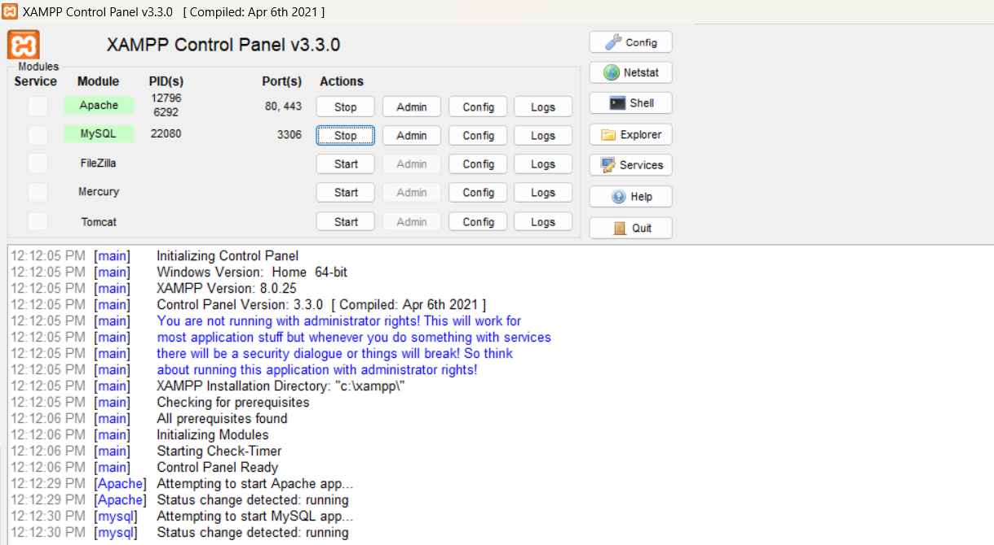

Figure [8]: - [XAMPP Control Panel]

**[2]: - NOTEPAD++.**

* Notepad is a generic text editor included with all versions of Microsoft Windows that lets you create, open, and read plaintext files with a .txt file extension. If the file contains special formatting or is not a plaintext file, it cannot be read in Notepad. The image shown here is a small example of what the Notepad may look like while running.
* Trying to create anything other than a basic plain text file can be difficult in Notepad. If you are looking for a free alternative to Notepad, we highly recommend NPP (Notepad++), an excellent free and open-source alternative. Notepad++ supports syntax highlighting, regular expressions, autocomplete, and more.
* **Figure of NOTEPAD++: -**

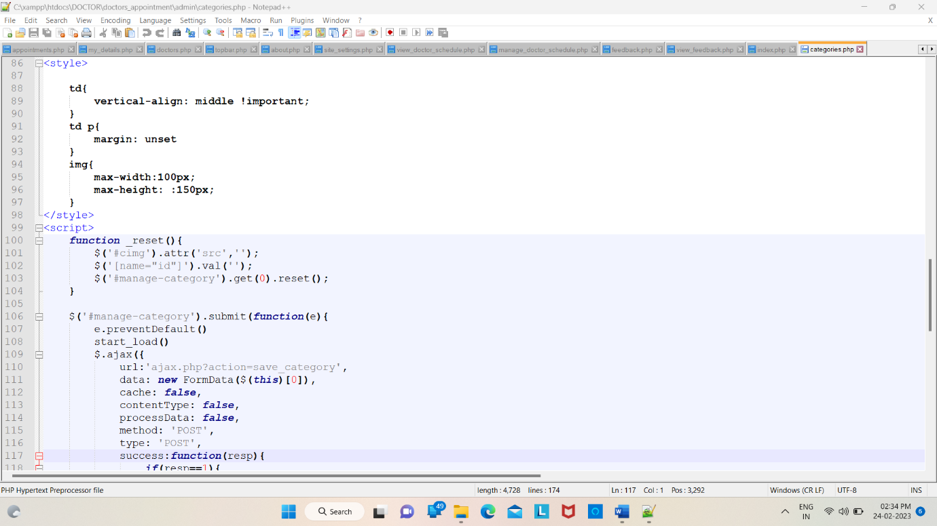

Figure [9]: - [NOTEPAD++

**[3]: - MYSQL.**

* A database is a separate application that stores a collection of data. Each database has one or more distinct APIs for creating, accessing, managing, searching and replicating the data it holds.
* Other kinds of data stores can also be used, such as files on the file system or large hash tables in memory but data fetching and writing would not be so fast and easy with those type of systems.
* Nowadays, we use relational database management systems (RDBMS) to store and manage huge volume of data. This is called relational database because all the data is stored into different tables and relations are established using primary keys or other keys known as Foreign Keys.
* **Figure of MYSQL: -**

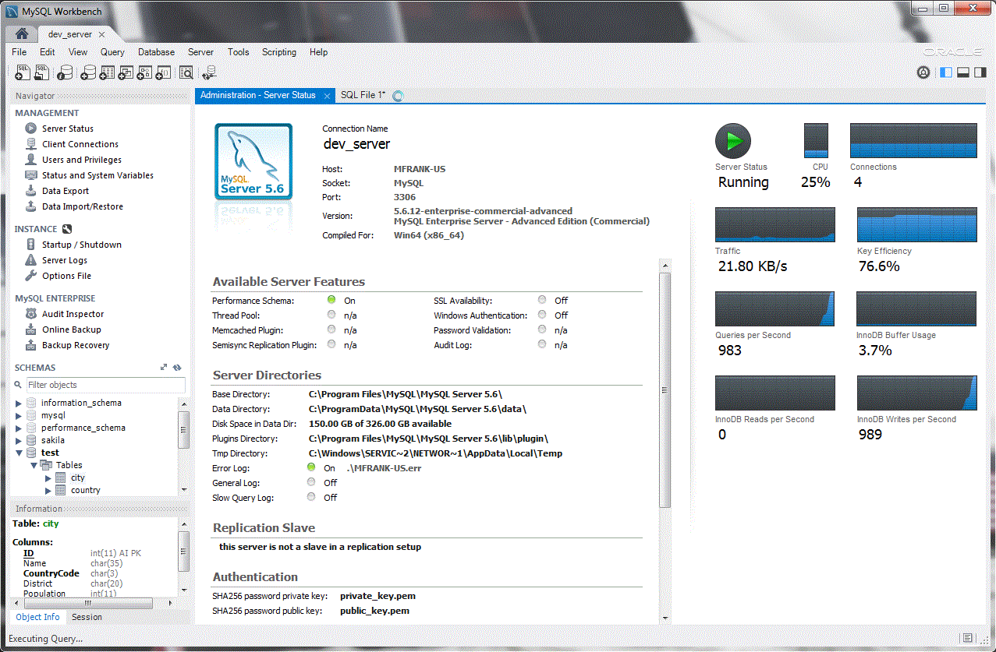

Figure [10]: - [MYSQL]

CHAPTER: - 5

CONCLUSION

5.1 CONCLUSION

* Doctor and patient appointment system is a very exciting topic to work. After going through the work, we faced many challenging tasks. Day by day healthcare system become an important part of our society. So, we have decided to build this system.
* We researched so many systems that showed us the direction how to develop our system. We interact with the people that what type of problem they facing. They were very happy to take this system as it is given them some relief in modern age.
* Despite everything we achieved, we faced many challenges to finish this project. After all it’s an online web-based system so in real life both doctor and patient need to follow the using rules otherwise its goal will be failed.
* **Good Point: -**

1. Security.
2. Performance.
3. Extensible.
4. Dynamic content.
5. Robust.

* **Week Point: -**
* Dependency to others projects and plug-ins.
* **Problem: -**
* During the development of project, it is inevitable for us to meet some Difficulties such as: -

1. Not enough time.
2. Learning new framework.
3. Learning Advance MySQL Query.

* **Perspective: -**
* Due to the time limitation, we have implemented only the main functionalities for the development of the Website. These functionalities are not sufficient to develop the project. Consequently, we will
  + - 1. Improve application performance.
      2. Finish the remaining functionality.

5.2 FUTURE SCOPE OF SYSTEM

* In the future we will update into android application. So, doctors and user no need to visit website.
* We will work for add more service on our “doctor’s appointment system” website.
* We will add online doctor consult in our website and also add map for doctor address.
* It will help a person to know the management of passed year perfectly and vividly.
* It also helps in current all works relative to Doctor Appointment System. It will be also reduced the cost of collecting the management & collection procedure will go on smoothly.
* This could be a revolutionary web application that may help bonding between doctor and patient. We believe we can make this system more advanced in future. Advance features and User interface will be updated in future. Our system is already user friendly but we will try to make this system more user friendly in future.
* When we look into the point of doctor appointment system development, cost-effectiveness and safety is the first that comes to mind. Using such an application, patients can reduce the number of hospital visits through remote interaction.
* This leads to less susceptibility to various diseases, as well as saving time and money on costly trips. With a more user-friendly doctor appointment app, patients are open to many useful options such as integration with calendars, online access to any doctor in any specialty, and ease of use for scheduling appointments.
* Doctors can better manage consultations this way. They can keep track of cancellations so that doctors will have a better chance of seeing one of their other patients if someone backs out of an appointment at the last minute.
* So, the doctor’s appointment system brings more than convenience for doctors. Automation can streamline many operational and billing processes for greater efficiency and profitability.

5.3 LIMITATION OF SYSTEM

* Present system carries certain drawbacks and limitations as listed below: -

1. Current system provides only multiple choices but single correct answer selection. Faculty may wish to provide multiple choices multiple selection responses.
2. In case questions and/or answers need to being graphics, current system has no provision.
3. Unregistered users cannot answer test, they must belong to some group. This is a drawback in case the faculty wants anyone even anonymous users to answer the test.
4. Top score could be displayed on the home page; but this could be easily implemented while programming the home page.
5. Security logs though not implemented in this system would be well available through the respective database management system and web server software.

5.4 BIBLIOGRAPHY

* **Visited Web Links: -**

1. <http://www.google.com/>
2. <https://www.youtube.com/>
3. <https://www.w3school.com/>
4. <https://www.tutorialspoint.com/>